**Development of**

**Job Recruitment Portal**



**Mohammad Ahsan Junaid**

**Abdul Rehman**

**Thesis submitted in partial fulfillment of requirements for the Degree of Bachelor of Sciences in Computer and Information Sciences**

**Department of Computer and Information Sciences, Pakistan Institute of Engineering & Applied Sciences, Nilore, Islamabad, Pakistan.**

**May, 2023**



***In the name of Allah, the Entirely Merciful, the Especially Merciful***

**Department of Computer and Information Sciences,**

**Pakistan Institute of Engineering and Applied Sciences, Nilore, Islamabad 45650, Pakistan**

**Declaration of Originality**

I hereby declare that the work contained in this thesis and the intellectual content of this thesis are the product of my own work. This thesis has not been previously published in any form nor does it contain any verbatim of the published resources which could be treated as an infringement of the international copyright law.

I also declare that I do understand the terms ‘copyright’ and ‘plagiarism,’ and that in case of any copyright violation or plagiarism found in this work, I will be held fully responsible for the consequences of any such violation.

**Certificate of Approval**

***This is to certify that the work contained in this thesis entitled***

**“Development of a Web Application, Job Recruitment**

**Portal”**

***was carried out by***

**Mohammad Ahsan Junaid**

**Abdul Rehman**

***Under our supervision and that in our opinion, it is fully adequate, in scope and quality, for the degree of BS Computer and Information Sciences from Pakistan Institute of Engineering and Applied Sciences (PIEAS).***

***Approved by:***

**Signature: Supervisor: *Dr. Anila Usman***

**Signature: Co-Supervisor: *Sir Irfan Hameed***

***Verified by:***

**Signature: Head, DCIS: Dr. Javaid Khurshid**

**Stamp:**

**This project is dedicated to our beloved family, teachers and friends, who offered us unconditional love and support throughout the course of this project.**

**Acknowledgement**

First and foremost, I would like to thank Allah, our sole creator, helper, guider, endower of everything that we have in our lives and forgiver for all the sins that we are guilty of committing. If it wasn’t for His enormous bounty, we would have never achieved anything in our lives and be lost.

I express my sheer appreciation to my supervisor Dr. Anila Usman. She has always been keen on helping and has provided me the guidance on every aspect concerning my project. Even with her grueling schedule she has always taken out time to clear away our doubts or solved any problem which impeded my work.

I also express my sheer appreciation to my co-supervisor, Sir Irfan Hameed. He has always been there for me whenever I needed him, and he has provided me with the necessary guidance on how to proceed with my project. He has helped me immensely in understanding the fundamentals of web development.

Lastly but most importantly I would express my eternal gratitude towards my parents who have always been our backbone throughout the years and have never let me down no matter what.

**Mohammad Ahsan Junaid**

**Abdul Rehman**

**PIEAS, Nilore, Islamabad**

**Table of Contents**

Contents

Abstract 1

Chapter 1: Introduction 2

1.1. Problem Definition 2

1.2. Proposed System 3

1.3 System Functions 4

Chapter 2: Literature and Tech Review 5

2.1. Management Portal 5

2.2. Programming Languages and Frameworks 5

2.2.1. HTML 5

2.2.2. CSS 6

2.2.3. JavaScript 6

2.2.4. Bootstrap 7

2.2.5. PHP 7

2.2.6. MySQL 7

2.3. Software’s and Technologies Used 8

2.3.1. XAMPP 8

2.3.2. Visual Studio 8

2.3.3. Apache 9

2.3.4. Github 9

2.3.5. phpMyAdmin 10

2.3.6. 000WebHost 10

Chapter 3: Software Design & Architecture 11

3.1. System Overview 11

3.2 Functional Requirements 11

3.2.1. Users / Applicant 11

3.2.2. Employers 11

3.3 Non Functional Requirements 12

1. Security 12

2. Availability 12

3. Scalability 12

4. Performance 12

5. Usability 12

3.4 System Architecture 13

3.4.1. Client-Side Elements 13

3.4.2. Components for the server 13

3.4.3. Infrastructure Elements 13

3.4.4. Application Layer 13

3.4.5. Database Layer 13

3.5. Database Design 14

3.5.1. Data Storage 14

3.5.2. Data Security 14

3.5.3. Data Organization 14

3.5.4. Data Scalability 14

3.5.5. Data Persistence 14

3.6. Scope 15

3.6.1. Features Falling Within Scope 15

3.6.2. Scope in Real World Use 16

Chapter 4: Implementation 17

4.1. Technology & Tools Used 17

4.2. Front End Development 17

4.2.1. Home Page 17

4.2.2. Job Posting Page 19

4.2.3. Login Page 20

4.2.4. Applicant Login Page 21

4.2.5. Employer Login Page 22

4.2.6. Sign Up Page 23

4.2.7. Applicant Registration Page 24

4.2.8. Employer Registration Page 25

4.2.9. Applicant Dashboard – Edit Profile 26

4.2.10. Applicant Dashboard – Job Applications 27

4.2.11. Applicant Dashboard – Mailbox 28

4.2.12. Applicant Dashboard – Read / Reply Mail 29

4.2.13. Applicant Dashboard – Settings 30

4.2.14. Employer Dashboard 31

4.2.15. Employer Dashboard – Company Details Page 32

4.2.16. Employer Dashboard – Create Job Page 33

4.2.17. Employer Dashboard – Posted Jobs 34

4.2.18. Employer Dashboard – Job Applications Page 35

4.2.19. Employer Dashboard – Mailbox 36

4.2.20. Employer Dashboard – Reply / Create Mail Page 37

4.2.21. Employer Dashboard - Settings 38

4.2.22. Employer Dashboard – Applications Database 39

4.2.23. Admin Dashboard 40

4.2.24. Admin Dashboard – Active Jobs 41

4.2.25. Admin Dashboard – Applicants Database 42

4.2.26. Admin Dashboard – Employers Database 43

4.3. Backend Development 44

4.3.1. How to Calculate Workload? 44

4.3.2. How to Handle Workload Weights? 44

4.4. Database Structure 45

4.4.1. Admin Table 46

4.4.2. Apply_Job Table 46

4.4.3. Cities Table 47

4.4.4. Companies Table 48

4.4.5. Countries Table 49

4.4.6. Job Post Table 49

4.4.7. Mailbox Table 50

4.4.8. Reply Mail Table 51

4.4.9. States Table 52

4.4.10. Users Table 53

4.5. Web Hosting 55

4.5.1. Backend Management 55

4.5.2. Database Management 56

Chapter 5: Structure 57

5.1. Front End Structural Diagram 57

5.2. Backend and Database Diagrams 58

5.2.1. ER Diagram 58

5.2.2. Use Case Diagram 59

5.2.3. Context Diagram 60

5.2.4. Relational Schema 61

Chapter 6: User Roles 62

6.1 . Administrator 62

6.2 . Employer 62

6.3 . Applicant / Candidate 62

Chapter 7: Conclusion and Future Works 63

7.1. Conclusion 63

7.2. Future Works 64

7.2.1. Live Interviewing: 64

7.2.2. Enhanced Search and Filtering: 64

7.2.3. Personalized Recommendations: 64

7.2.4. Mobile Application: 64

References 65

Appendix B – React JS Installation and Setup 68

Appendix C – Libraries Used in Project 70

● Bootstrap 70

• React 70

• Axios 70

• React-Router-Dom 70

**Table of Figures**

# Abstract

The Job Recruitment Portal is a comprehensive web-based platform designed to help employers and applicants streamline the job recruitment process. The portal aims to connect job seekers and employers through an efficient and user-friendly interface, facilitating seamless job search, application, and selection procedures. The administration, employers, and applicants are the three main actors in the system. As the super user, the admin has the authority to manage the database, monitor system statistics, and perform other administrative tasks. Employers can post job openings, review applicant profiles, select or reject applicants, and download resumes as well as contact applicants through the in-built mailbox. Applicants, on the other hand, can search available job listings, apply for relevant positions, and showcase their qualifications through resume submissions. The Job Recruitment Portal aims to improve the efficiency and effectiveness of the job recruitment process for both employers and applicants by providing a centralized platform for job posting and application management. To ensure a robust and password protected secure system, the project employs a number of technologies and frameworks. We investigate the design, development, and evaluation of the Job Recruitment Portal, as well as its performance and potential future enhancements, in this thesis. The outcomes demonstrate the system's effectiveness in facilitating seamless job recruitment procedures and improving the overall experience for both employers and applicants.

# Chapter 1: Introduction

The Job Recruitment Portal aims to revolutionize the job recruitment process by providing employers and applicants with a user-friendly and efficient platform. Traditional methods of recruitment frequently result in delays, inefficiencies, and missed opportunities. This project addresses these issues by providing a centralized system with three primary actors: administrator, employers, and applicants. The database and system statistics are managed by the administrator, while employers can post jobs, review applicants, and download resumes. Applicants can look for jobs and apply for them. The portal makes use of technologies and frameworks to ensure a stable system. The focus of evaluation is on performance, usability, and user satisfaction. The findings contribute to the field of job recruitment and provide guidance for future improvements. The goal is to improve the overall experience for employers and applicants by streamlining the recruitment process, saving time and effort.

## Problem Definition

Traditional recruitment methods frequently face a number of challenges that impede the process's efficiency and effectiveness.

* Handling a large volume of job applications manually is time-consuming and labor-intensive, resulting in delays and potential oversight of qualified candidates.
* Job seekers struggle to find relevant opportunities among numerous sources, resulting in potential positions being missed.
* The lack of standardized formats for resumes and job postings makes objective candidate evaluation and decision-making difficult.
* Without a centralized system, employers struggle to effectively track and manage applications.
* Limited Reach and Narrow Candidate Pool: Conventional techniques, such as newspaper ads or physical job postings, may only reach a narrow pool of individuals. Due to this, there may be a lack of diversity and skilled applicants who are not actively looking for work through conventional routes may go unnoticed.
* High costs: Conventional hiring practices can be pricey, including participating in job fairs and newspaper advertising. Advertising, travel, and other associated costs may require organizations to set aside large sums. This can be difficult, especially for startups and small businesses with scarce resources.
* The management of applications, paperwork, and communication can be inefficient and prone to mistakes when done manually. Traditional techniques frequently lack automated components.

## Proposed System

The solution for this is a modern “Job Recruitment Portal”, As the world moves on to a digital era, searching for Jobs or finding the right Employee for one, like all other aspects of daily life, are being shifted to be online, saving time, human resources, accessible and providing ease of use. We intended to create a platform that will automate the process where organizations can put up job vacancies, where applicants can go through them and apply in the right job.

Where employers would have the ease of checking through CV’s and selecting the suitable candidates etc. And applicants will find a platform that will allow them to apply in multiple jobs according to their qualifications easily as well as get side-by-side updates.

It is web-based platform, with a good UI/UX having a Landing page, Job Vacancies Page from where one can apply into preferred job after registering with the system as an applicant where email validation shall be done, then provide data and upload their CV and apply for jobs they want, they can also search by the search bar and apply search filters for their needs like locations, experience requirements etc. Employers would have access to a job posting page where they set the requirements and the details of the job like title, salary, details etc. This system has a database for all records of jobs i.e. Job Titles (with details), Applications (CV attached, Data provided) as well as details of users such as employers, and most importantly the applicants like their Names, CNIC, Addresses, Qualifications, and so on.

To secure all this data and avoid mishaps, security measures will be taken starting off with proper Authorization being implemented like access-controls over user types, where an applicant can only view, update his/her own data rather than having access of others, the employer only accessing data of applicants who have applied to his posted job, Admin having access of everything including the database etc.

Applicants/Candidates can apply in one or more jobs with easy without entering same data (name, CNIC, Addresses etc.) again for each job they apply. On the employers end they can check all the applications to a certain job, contact applicants regarding concerns through in-built communication channel and download CV’s and data of applicants for further processing if needed.

## 1.3 System Functions

The following are key system functions:

* **User Registration and Login Authentication:**

Employers and Applicants can register and create accounts on the portal, that are password protected and encrypted in database, hence even admin cannot see them.

User login authentication ensures secure system access and protects user data.

* **Job Posting and Management:**

Employers can create and post job openings, describing the job's details and requirements.

As needed, job listings can be edited, updated, or removed.

* **Filtering and Job Search:**

Applicants can use specific criteria to search for available jobs. Filtering options allow applicants to refine their search results and find relevant job opportunities.

* **Management of Applicant Profiles:**

Employers can review applicant profiles, including resumes, can establish contact if they have applied to any job posting by that employer.

* **Candidate Selection:**

Based on their suitability for the job, employers can mark applicants as selected / rejected.

Selected candidates can be contacted for interviews, assessments, or other stages of the selection process through the in-built mailbox.

* **Download Resume/CV:**

Employers can download applicants' resumes or CVs for offline review or further evaluation.

* **Management and the Admin Dashboard:**

The system administrator has access to a comprehensive dashboard for system management.

Admin functions include approval of employer account, managing users, databases, and generating system statistics. Admin reserves rights to delete any posted job, or employer account as well from here.

* **In Built Mailbox:**

The in-built mailbox offers applicants and employers to communicate any misunderstandings or important notices and details.

* **Change Password / Deactivate Accounts:**

Employers and applicants can both use this option to modify their passwords inside the portal. To ensure account security, users can reset their passwords and access their account settings. Users are also able to deactivate their accounts within the portal.

# Chapter 2: Literature and Tech Review

Chapter 2 contains many basic concepts, technologies and frameworks that are significant in the conduct and development of the project titled “*Job Recruitment Portal”.*

## Management Portal

Information systems are large, linked collections of information, data and processes. They are employed in virtually every element of human life, business, and industry.

The phrase "information system" in technology refers to any tool or information system that facilitates the gathering and utilization of data. Information systems can be utilized to give aid inside a company or for personal benefit.

A good information system enables the user to quickly access, comprehend, and react to information. Users get access to the most up-to-date information whenever they need it to complete a task.

## Programming Languages and Frameworks

In this section, different technologies and tools that can be used to develop this information system are discussed.

### HTML

A common markup language for building and organizing web pages is HTML (Hypertext Markup Language). It offers a collection of tags that specify the organization and display of content on the internet. Text, images, links, forms, and other elements can all be included in HTML and displayed in a web browser. It offers a logical, hierarchical structure that enables web designers to efficiently organize and format the content. Developers can use HTML to build semantically sound web pages that are compatible with assistive technology and search engines. Along with JavaScript and CSS (Cascading Style Sheets), HTML is a core language used in modern web development. All of the main web browsers support it, ensuring cross-platform compatibility.

### CSS

CSS is a style sheet language that is used to describe the presentation and formatting of HTML and XML documents. It provides a set of rules and properties that control how web pages look visually. CSS allows web designers to separate a webpage's content from its presentation, providing greater flexibility and consistency across multiple pages. Designers can define various aspects such as colors, fonts, layout, and animations by applying CSS to HTML elements. CSS encourages efficient web development by allowing the reuse of styles across different pages, making it easier to maintain and update a website's overall design. It works with HTML to create visually appealing and responsive web pages. Web designers have precise control over the aesthetics of their websites with CSS, which improves the user experience and overall presentation of content.

### JavaScript

JS (JavaScript) is an interpreted high-level programming language that is primarily used to add interactivity and dynamic behavior to web pages. All modern web browsers support it, allowing developers to create interactive elements, perform calculations, manipulate web page content, and respond to user actions in real-time. JavaScript can be embedded directly within HTML documents or included as separate files, improving website functionality and user experience. It includes event handling, DOM manipulation, AJAX for asynchronous communication, and the ability to create interactive web applications. It is a versatile language that can be used in server-side environments, mobile app development, and other software projects in addition to web development.

### Bootstrap

Bootstrap is a popular front-end framework for developing responsive and mobile-first websites. Bootstrap, created by Twitter, is a collection of pre-designed templates, CSS styles, and JavaScript components that make it easier to create modern and visually appealing web pages. It uses a grid-based layout system, which allows developers to easily arrange and align page elements. Bootstrap also includes a plethora of reusable user interface components, such as navigation bars, buttons, forms, modals, and carousels, that can be easily customized and integrated into web projects. Because it is built with HTML, CSS, and JavaScript, it is compatible with all modern web browsers. Bootstrap provides developers with a time-saving and efficient solution for creating responsive and professional-looking websites, thanks to its extensive documentation and active community support.

### PHP

PHP (Hypertext Preprocessor) is a popular server-side scripting language that is used in web development. It is primarily used for the development of dynamic and interactive web pages and web applications. PHP code is embedded directly into HTML, allowing developers to seamlessly mix logic and presentation. PHP is a versatile programming language that can interact with databases, handle form data, generate dynamic content, and perform a variety of server-side tasks. It is supported by the majority of web servers and runs on a variety of operating systems, making it extremely accessible. PHP includes a large number of built-in functions and libraries that help to simplify common web development tasks. PHP allows developers to create robust and scalable web applications that power some of the internet's most popular websites.

### MySQL

MySQL is a relational database management system (RDBMS) that is free and open source that allows for the efficient storage, management, and retrieval of structured data. MySQL employs a client-server architecture, in which the server manages and stores data, while clients (such as applications or websites) interact with the server to perform various database operations. MySQL provides a robust and scalable solution for data-driven applications by supporting SQL (Structured Query Language) for querying and manipulating data. It includes data security, transaction support, and support for a variety of data types and indexing mechanisms. MySQL is well-known for its speed, dependability, and simplicity of use, making it a popular choice for both small-scale projects and enterprise-level applications.

## Software’s and Technologies Used

In this section, different technologies and tools that can be used to develop this portal are discussed.

### XAMPP

XAMPP is a free and open-source software package that includes everything needed to set up a local web server environment. "XAMPP" is an abbreviation for cross-platform (X), Apache (A), Maria DB (M), PHP (P), and Perl (P). It contains all of the components required to run dynamic web applications on a local machine, making it an excellent choice for developers and web designers. XAMPP is a pre-configured package that includes the Apache web server, the Maria DB (formerly MySQL) database management system, the PHP scripting language, and the Perl programming language. It also includes tools for database administration, such as phpMyAdmin, and a file transfer server, FileZilla. XAMPP works with a variety of operating systems, including Windows, macOS, and Linux. It makes it easier to set up a local development environment, allowing users to test and debug web projects before deploying them to a live server. Because of its ease of installation, comprehensive feature set, and community support, XAMPP is widely used by both developers and beginners.

### Visual Studio

Microsoft Visual Studio is an integrated development environment (IDE) that offers a comprehensive set of tools and features for software development. It supports a wide range of programming languages and frameworks, including C#, C++, Visual Basic, and.NET. Visual Studio is an easy-to-use and highly productive environment for developing, debugging, and deploying applications across multiple platforms and devices. It has code editors, project management tools, integrated debugging capabilities, and a large collection of libraries and extensions. Visual Studio also integrates seamlessly with source control systems, allowing developers to effectively collaborate on projects. Visual Studio has become a go-to choice for professional developers and students alike, thanks to its powerful features, extensive documentation, and supportive community. Visual Studio provides the tools and resources needed to streamline the development process and deliver high-quality software, whether you're creating desktop applications, web applications, mobile apps, or cloud-based solutions.

### Apache

If Apache, also known as Apache HTTP Server, is a popular open-source web server. It is one of the most widely used and long-lasting web server solutions available. Because of its flexibility, stability, and performance, Apache is a popular choice for hosting websites and serving web content. It works with a variety of programming languages and frameworks and supports multiple operating systems, including Windows, Linux, and macOS. URL rewriting, SSL/TLS encryption, virtual hosting, and load balancing are just a few of the features and modules available to enhance Apache's functionality. It has strong security measures and customizable configuration options, allowing administrators to tailor the server to their specific requirements. Because of the extensive community support and documentation provided by Apache, it is accessible to both novice and experienced users. Overall, Apache is a dependable and feature-rich web server software that has remained a mainstay of the web hosting industry.

### GitHub

GitHub is a web-based platform that provides hosting for version control repositories. It enables developers to effectively collaborate on projects, track changes, and manage source code. Developers can use GitHub to create repositories to store their code and easily share and collaborate with others by inviting contributors to join their projects. The platform includes features like branching and merging that allow developers to work on different versions of the code at the same time and seamlessly merge their changes. GitHub also has an issue tracking system, which allows developers to report and track bugs or feature requests within a project. It also includes a robust code review system that allows peers to review and provide feedback on each other's code changes. GitHub hosts millions of public repositories as an open-source community, making it a valuable resource for discovering and contributing to a wide range of projects. It has evolved into a necessary tool in modern software development, encouraging collaboration, code sharing, and community-driven innovation.

### phpMyAdmin

phpMyAdmin is a graphical user interface (GUI) tool for managing and administering MySQL databases that is accessible via the web. It has an easy-to-use interface that allows users to perform database operations like creating and managing databases, tables, and indexes, running SQL queries, importing and exporting data, and managing user privileges. phpMyAdmin makes it easier to manage MySQL databases, especially for users who are unfamiliar with the command-line interface. Users can easily interact with their databases thanks to its user-friendly interface, making it a valuable tool for web developers, database administrators, and system administrators. phpMyAdmin is written in PHP and supports multiple languages, allowing users all over the world to have a localized experience. It is a widely used tool because of its ease of use, robust features, and active community support. phpMyAdmin is a convenient and powerful solution for managing MySQL databases, whether used for small-scale projects or large-scale enterprise applications.

### 000WebHost

000webhost is a free web hosting platform that allows users to host their websites at no cost. It has an easy-to-use interface and a variety of features that make website building and management easier. Users can enjoy free web hosting services with 000webhost without the requirement to invest in a dedicated hosting solution. Users may create dynamic and interactive websites because to the platform's support for PHP and MySQL. It includes a website builder and is compatible with popular content management systems (CMS) such as WordPress. While 000webhost is free, it does have some restrictions, like restricted storage space, bandwidth, and server resources. phpMyAdmin is an easy and powerful tool for administering MySQL databases, whether used for small-scale projects or large-scale enterprise applications.

# Chapter 3: Software Design & Architecture

## 3.1. System Overview

The purpose of the project is to develop a Job Recruitment system that provides all the necessary information or details of jobs available, allowing applicants to opt those and employers to check resumes and select / reject application.

## Functional Requirements

### 3.2.1. Users / Applicant

1. Registration: Applicants should be able to create an account by providing their personal details and creating login credentials.

2. Login: Applicants should have the ability to log into their accounts using their registered email and password.

3. Forgot Password: Applicants should have an option to recover their forgotten password through a password reset process.

4. Update Profile: Applicants should be able to edit and update their profile information, including personal details, work experience, education, and skills.

5. View Jobs: Applicants should have access to a list of job openings, with the ability to search, filter, and browse through available positions.

6. Apply for Job: Applicants should be able to submit their applications for specific job listings, including attaching their resumes and any additional required documents.

7. Upload Resume: Applicants should have the ability to upload their resumes or CVs to their profiles for employers/recruiters to review during the application process.

### 3.2.2. Employers

1. Registration: Employees should be able to create an account on the job portal by providing necessary personal information and contact details.

2. Login: Employees should have the ability to securely log into their accounts using their registered credentials.

3. Forget password option: Employees should have the option to recover/reset their forgotten passwords through a secure process.

4. Select/reject: Employees should be able to select or reject job applicants based on their qualifications and suitability for the position.

5. Add Job posts: Employees should have the capability to create and post job openings with relevant details such as job title, description, requirements, and application instructions.

6. Delete Job posts: Employees should be able to remove job posts from the portal once the position has been filled or is no longer available.

7. Search, view, or download resume of applicants: Employees should be able to search for specific job applicants, view their resumes, and have the option to download or save them for further evaluation.

## Non Functional Requirements

### Security

To ensure confidentiality and prevent unauthorized access, the system should put appropriate security safeguards in place, such as encryption, secure authentication, and access controls.

### 2. Availability

The job portal should always be available and functional, offering users uninterrupted service with minimal downtime.

### 3. Scalability

Without noticeably degrading in performance, the system should be able to handle an increasing number of users, job postings, and resumes.

### 4. Performance

Even with high traffic and large records, the portal should offer a quick and responsive user experience, with quick loading times for pages and search results.

### 5. Usability

The portal's interface should be simple and easy to use, making it simple for both employers and job seekers to navigate, look for jobs, and manage profiles and applications.

## System Architecture

A Job Recruitment Portal's system architecture is client-server, with various components interacting to provide the desired functionality. A high-level overview of the system architecture is provided below:

### 3.4.1. Client-Side Elements

* UI (User Interface): This component represents the portal's frontend and is in charge of displaying the user interface to employers and applicants. To ensure a responsive and interactive experience, it is typically built with HTML, CSS, and JavaScript frameworks.

### 3.4.2. Components for the server

* The web server handles incoming client requests and serves the appropriate web pages. It handles communication between clients and backend services.
* The application server is where the Job Recruitment Portal's core business logic resides. It manages job listings, applicant data, and performs various operations based on user actions. It communicates with the database server in order to retrieve and store data.
* The database server stores and manages data from the portal, such as user information, job listings, applicant profiles, and application data.

### 3.4.3. Infrastructure Elements

* Networking: This component ensures that clients, web servers, application servers, and database servers are all connected. It is in charge of routing requests and responses across the network.
* Security: Security components are in charge of authentication, authorization, encryption, and secure communication protocols in order to protect user data and maintain system integrity.
* Storage: To store resumes, the system architecture includes storage components such as file servers or cloud storage solutions.

### 3.4.4. Application Layer

* Contains the application's main logic for the job portal.
* It handles request processing, authentication, and business logic and is written in PHP.
* Interacts with the database layer to retrieve and modify data

### 3.4.5. Database Layer

* Manages data retrieval and storage.
* Uses a relational database management system (like MySQL) to keep track of user data, resumes, and other job-related information.

## Database Design

Our Web Application needs a database to store, organize, and manage data efficiently. The data can be of different types, including user information, Job information and so on.

### 3.5.1. Data Storage

A database provides a centralized location to store data for a web app. It allows data to be easily managed and retrieved by the application.

### 3.5.2. Data Security

Databases can provide security measures to protect sensitive information. It can limit access to specific data and protect against data breaches.

### 3.5.3. Data Organization

Databases allow data to be organized in a structured manner, making it easy to retrieve data based on specific criteria.

### 3.5.4. Data Scalability

Databases can handle large amounts of data, making it easy to scale up or down the application as needed.

### 3.5.5. Data Persistence

Databases ensure that data is saved even if the application is shut down or restarted. This makes it possible to continue from where the application left off.

Overall, a database is a crucial component of our web app, and it allows the application to store and manage data efficiently and securely. In order for a database we need tables that store the data for the portal, the tables created are as follows:

* admin
* apply_job_post
* cities
* company
* countries
* job_post
* mailbox
* reply_mailbox
* states
* users

## Scope

### Features Falling Within Scope

Here are some features that fall within the scope / covered by a job portal:

* + - 1. Job Listings: A job portal's main purpose is to offer a platform for employers to post open positions, and for job seekers to look for and apply to those positions. Employers should be able to specify job details, requirements, and application processes through the portal, which should also provide job seekers with search and filtering options.
      2. Candidate profiles: Typically, job portals have tools that allow applicants to create and manage their profiles. This could entail managing job applications, uploading resumes, providing personal and professional information, emphasizing skills and qualifications, etc.
      3. Employer Profiles: On the job portal, employers should be able to create and manage their profiles. This includes disseminating company information, publishing job listings, managing and reviewing application materials, and corresponding with applicants.
      4. Search and Filtering: Job seekers should have the option to search for positions based on a variety of factors, including location, industry, job type, level of experience, and keywords. The search results can be trimmed down to better match particular preferences using advanced filtering options.
      5. Application Management: The job portal should make it easier for both employers and job seekers to manage job applications. Reviewing, shortlisting, and corresponding with applicants should be possible for employers. Job seekers ought to be informed of the status of their applications and have access to their application history.
      6. Communication and Messaging: The portal might have messaging features that make it easier for job seekers and employers to communicate. Direct messaging, email alerts, or integration with other communication channels may be used for this.
      7. Resume Database: Some job portals give employers access to a database of resumes from candidates who have chosen to make their profiles searchable. Employers can proactively look for candidates thanks to this.

### Scope in Real World Use

They offer a central hub for connecting job seekers and employers, making it simpler for employers to find qualified candidates and for job seekers to research job opportunities, and make job openings more visible to both employers and job seekers. Wider audiences can be reached by employers, improving the likelihood of luring in qualified candidates.

It can also be used as follows:

1. Public job portals: Easily accessible job listings and open government hiring.

2. Private Job Portals: With a centralized recruitment platform, businesses can streamline their hiring processes.

3. Industry-Specific Portals: These websites link job seekers and employers in specialized fields.

4. University portals: Alumni and students can access internships and jobs.

5. International job opportunities are listed on global job portals.

6. Freelance Job Portals: These sites help match independent contractors with clients for project-based work.

# Chapter 4: Implementation

## Technology & Tools Used

The technologies and frameworks that are used to develop system are;

* + 1. Bootstrap
    2. PHP
    3. MySQL
    4. Apache
    5. Xampp
    6. Visual Studio
    7. Brackets

## Front End Development

The process of developing a website's user interface and interactive elements is known as front-end development.

1. The common markup language used to organize the content of web pages is HTML. It outlines the page's structure and elements, including headings, paragraphs, images, forms, and more.

2. A stylesheet language called CSS is used to describe the presentation and styling of an HTML document. It gives you the ability to manage how elements, such as colors, fonts, layouts, and responsive design, appear.

3. JavaScript is a web-based programming language that gives web-pages interactivity and dynamic functionality. You can work with HTML elements, manage events, send AJAX requests, and make animations.

.

### Home Page

The following features would be displayed on the home page's output:

* Navigation Menu:  
  Depending on their session status, users can access various website sections such as "Jobs," "Login," "Sign Up," "Dashboard," and "Logout" via a navigation menu that would be visible in the header.
* Latest Jobs section:  
  Shows details about the newest job listings. The job title, employer name, location, level of experience necessary, and maximum salary is all listed. For up to four job listings, the data is dynamically retrieved from the database and displayed in a loop.
* Stats section:  
  statistical data regarding the job portal. It lists the total number of positions available, employers who have registered, CVs and resumes, and users overall. Additionally, dynamically retrieved from the database are these statistics.

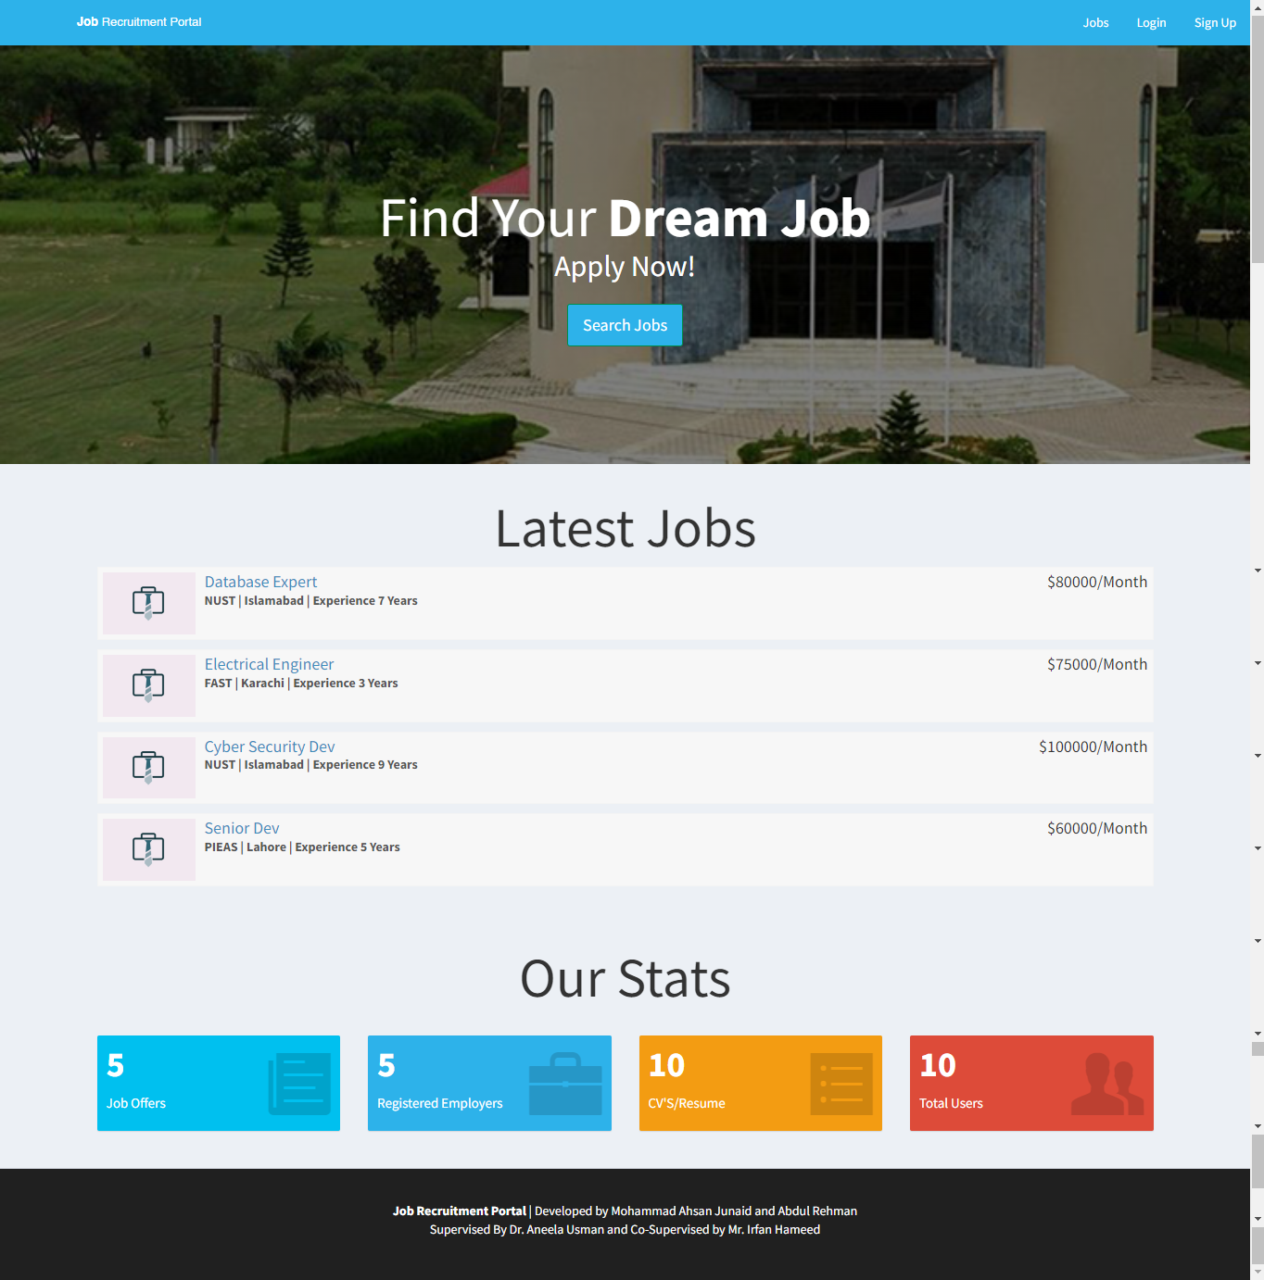

Figure 4. 1

### Job Posting Page

The following features would be displayed on the page's output:

* Navigation Menu:  
  Depending on their session status, users can access various website sections such as "Jobs," "Login," "Sign Up," "Dashboard," and "Logout" via a navigation menu that would be visible in the header.
* Search Jobs:  
  To search for jobs, users can enter a search term and press the button.
* Filters Section:  
  The page has a section for filters where users can narrow down job listings by "City" and "Experience." Users may refine their search results using the options provided.
* Job Listings:  
  Based on the entered search terms or selected filters, the page dynamically loads job listings. Users can navigate through multiple pages of the job listings thanks to the pagination feature of the job listings.

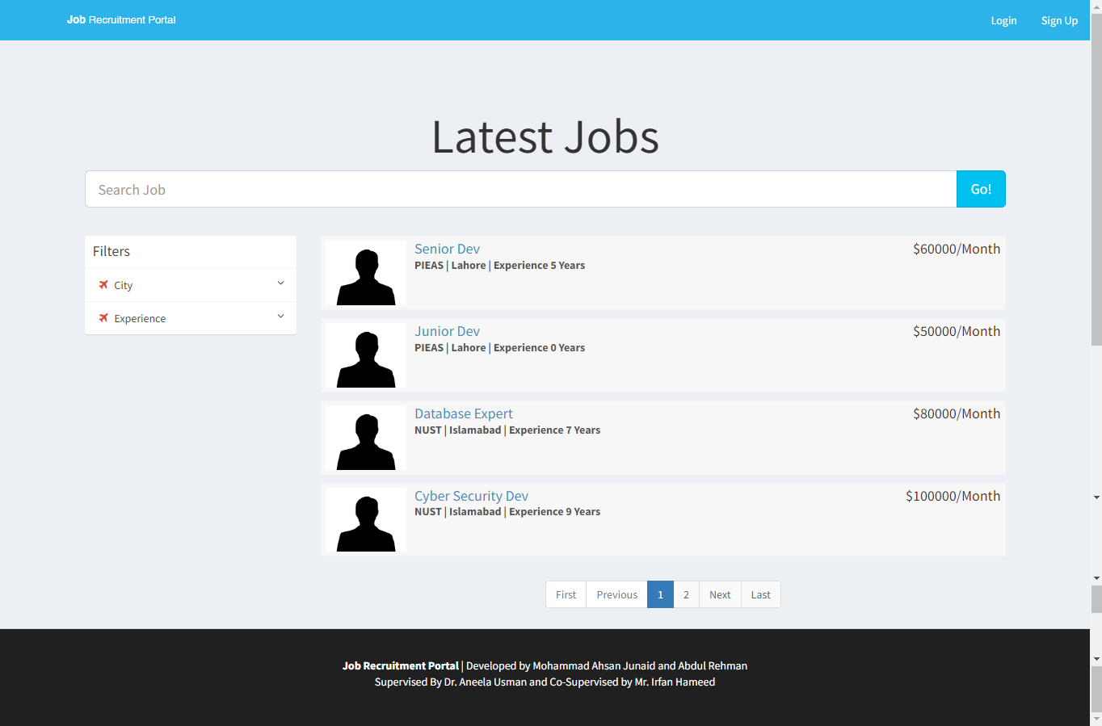

Figure 4. 2

### Login Page

The login page is designed to give users a user interface to access the job recruitment portal. There are two ways to log in: "Applicant Login" and "Employer Login." Users can enter their login information and authenticate themselves on this page in order to access their individual dashboards.

* Login Options:  
  Two login options are shown in the content header section: "Applicant Login" and "Employer Login." Users can access the login pages for employers and applicants by clicking on the corresponding links.

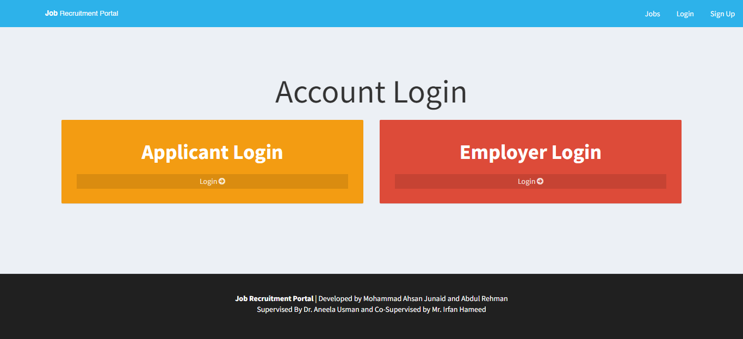

Figure 4. 3

### Applicant Login Page

The following features would be displayed on the page's output:

* Session Check: This checks for session variables (such as "$_SESSION['id_user'] or "$_SESSION['id_company']) to see if the user is already logged in. The user is directed to the 'index.php' page if they are already logged in.
* Login Form: Applicants can authenticate themselves by entering their email and password in the login form. The 'action' attribute of the form is set to 'checklogin.php', indicating that the form's data will be sent there for additional processing.
* The form has a link for password recovery if you've forgotten it. The appropriate action should start after clicking the link.

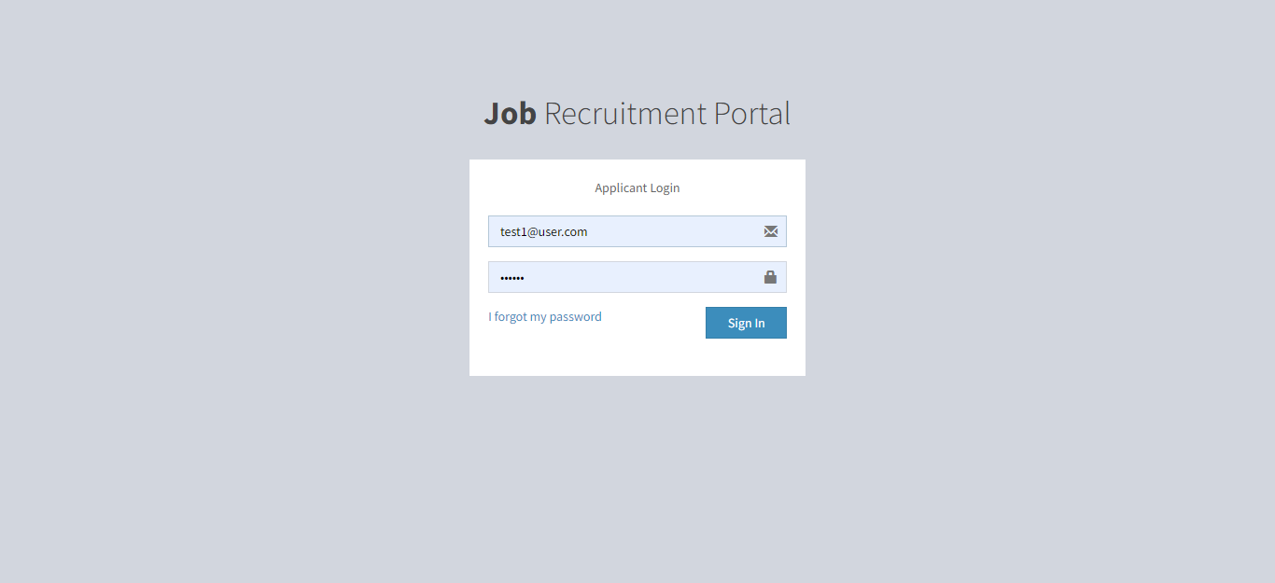

Figure 4. 4

### Employer Login Page

The following features would be displayed on the page's output:

* Session Check: This checks for session variables (such as "$_SESSION['id_user'] or "$_SESSION['id_company']) to see if the user is already logged in. The user is directed to the 'index.php' page if they are already logged in.
* Login Form: Employers can authenticate themselves by entering their email and password in the login form. The 'action' attribute of the form is set to 'checklogin.php', indicating that the form's data will be sent there for additional processing.
* The form has a link for password recovery if you've forgotten it. The appropriate action should start after clicking the link.

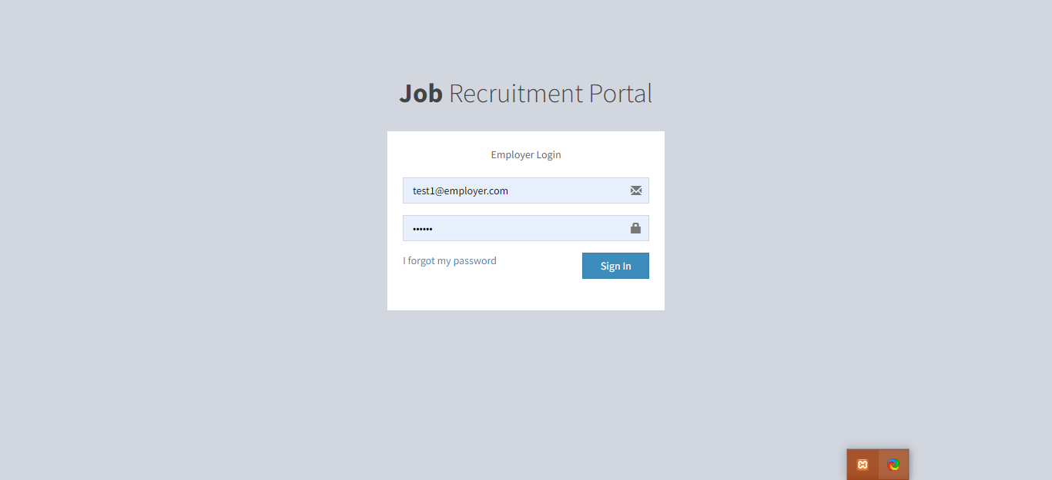

Figure 4. 5

### Sign Up Page

The provided code's primary function is to build a sign-up page for a job search engine. The two registration options available to users are "Applicant Registration" and "Employer Registration."

The page aims to make the registration process easier for people who are interested in either posting job listings as employers or applicants. The page offers users a clear and user-friendly interface for choosing their desired path by offering two distinct registration options in aesthetically pleasing boxes.

In general, this page's primary function is to act as a starting point for users to register and interact with the job recruitment portal, depending on whether they want to register as applicants or employers.

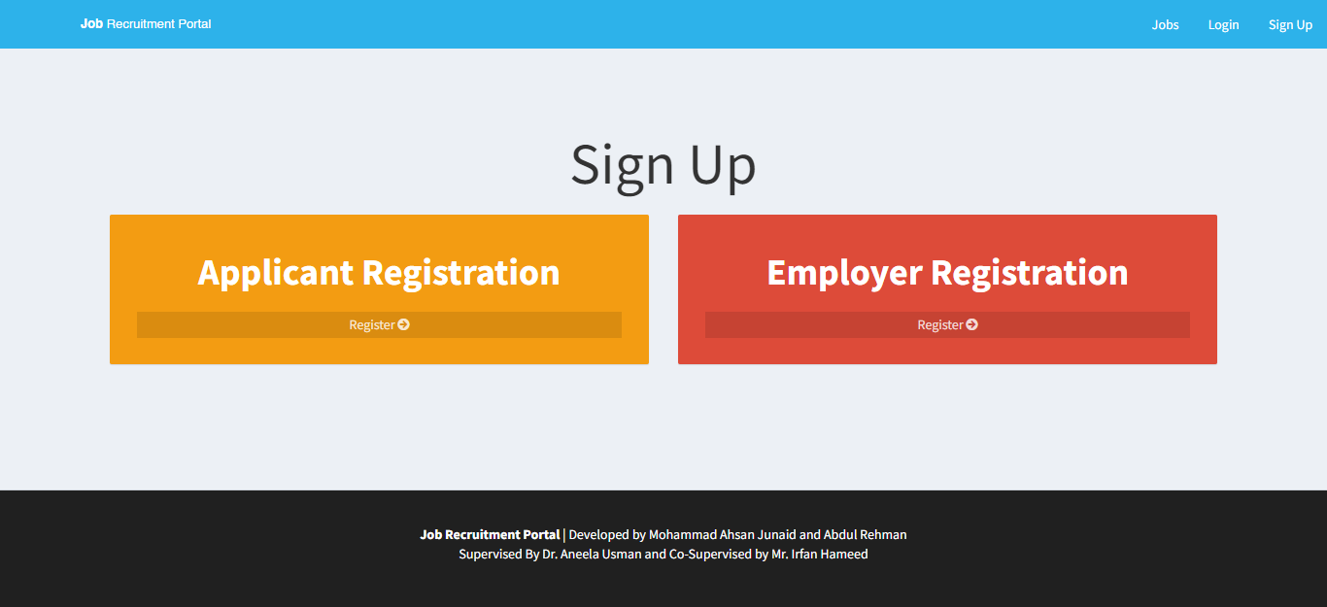

Figure 4. 6

### Applicant Registration Page

This page's objective is mainly a user sign-up form for applicants. The following are the features and functionalities:

* Users can enter personal information such as their first and last names, email addresses, CNICs (national identification numbers), short bios, dates of birth, ages, and graduation years, as well as their highest educational attainment and stream. Users can also upload their resumes (only in PDF format) and provide contact information.
* For data validation and restrictions, a variety of input fields have attributes like "required," "minlength," "maxlength," and "readonly."
* Dynamic Calculations: The script has JavaScript code that uses the user's selected date of birth to determine their age. The "Age" input field is then automatically updated with the calculated age.

.

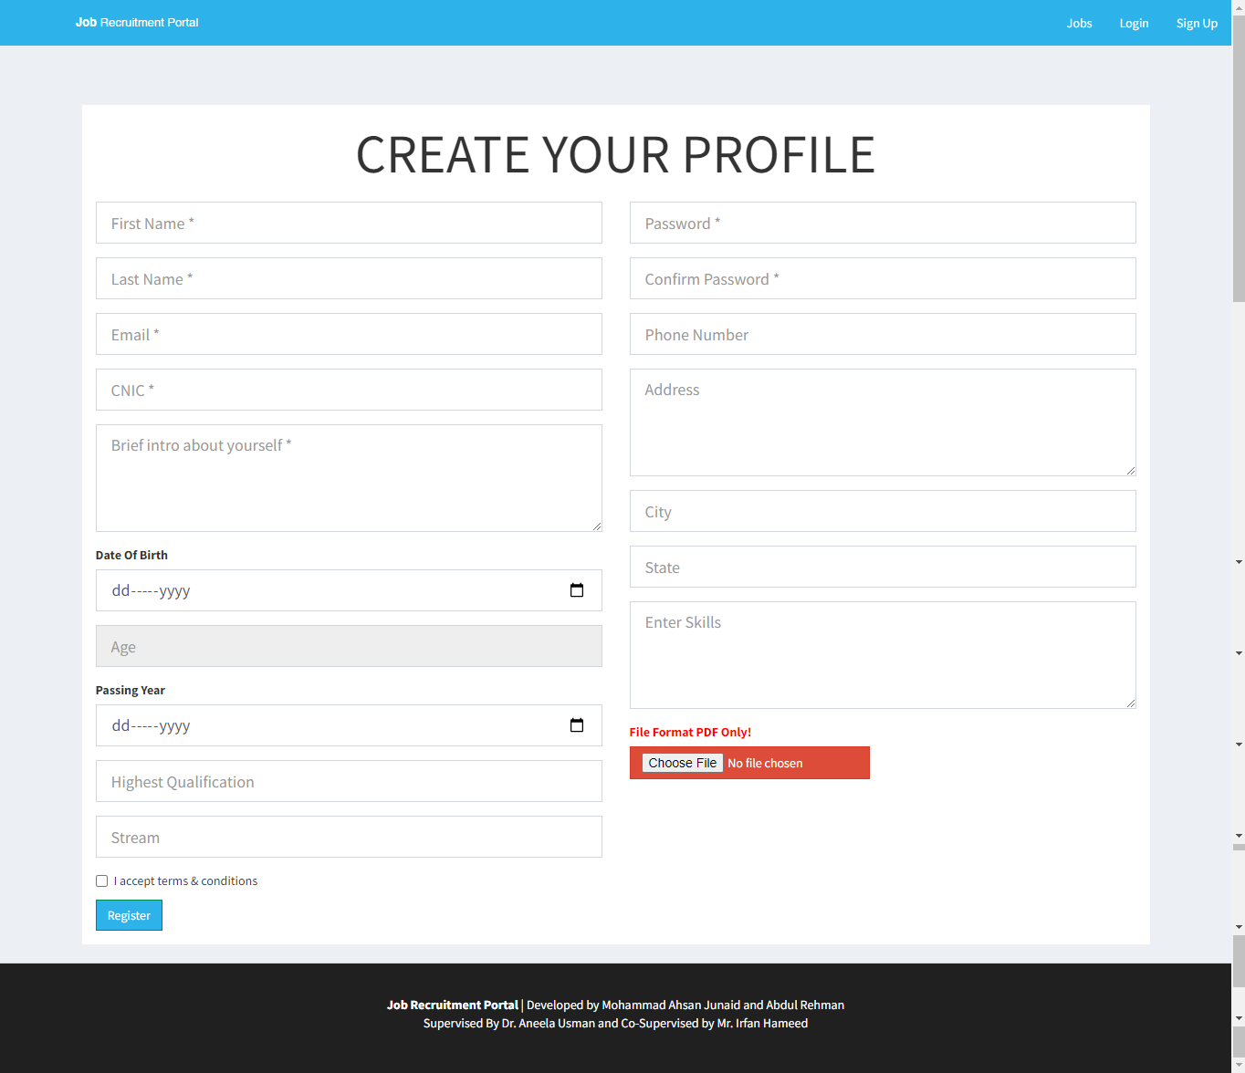

Figure 4. 7

### Employer Registration Page

The following features would be displayed on the page's output:

* Menu for navigating:  
  Depending on the user's authentication status, the navigation menu has options like "Jobs," "Login," "Sign Up," "Dashboard," and "Logout."
* Form of Registration:  
  Employers are able to enter information on the form, including their full name, company name, website, email, a brief description of their company, password, a phone number, and the city, state, and country where they are located.
* For data validation and restrictions, different form fields have attributes like required, minlength, maxlength, and autocomplete.

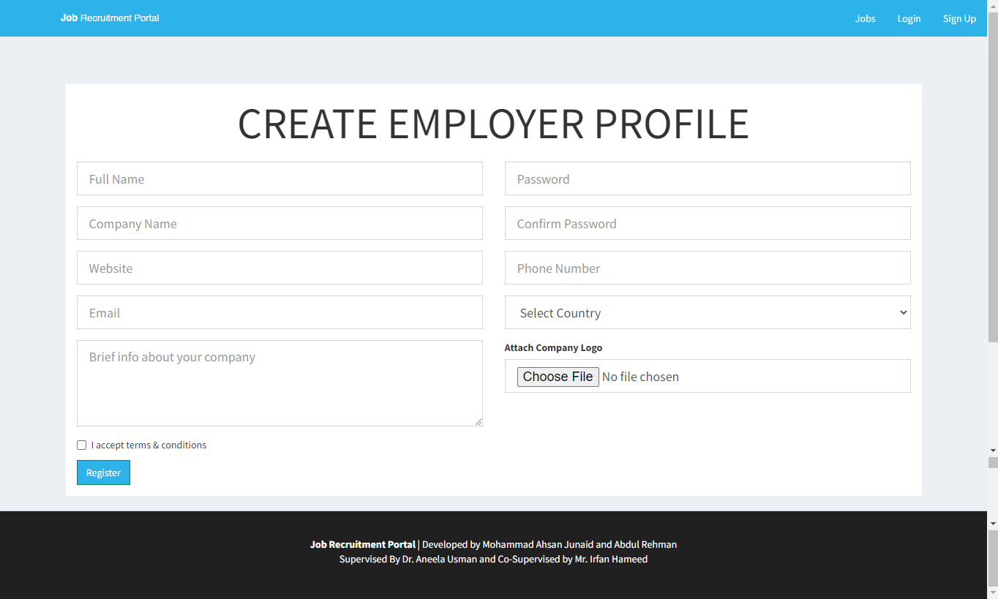

Figure 4. 8

### Applicant Dashboard – Edit Profile

Users who are logged in can edit their profile details on this page. The output page's features and capabilities include:

* Display of Profile Information: The user's information is retrieved from the database and shown in the form fields so they can see their current profile information.
* Users can update their profile information, including their first and last names, addresses, cities and states, phone numbers, highest educational qualifications, streams, and skills, as well as the "about me" section. The user's previous data is pre-filled into the form fields, making it simple to make changes.
* Users have the option of uploading or changing their resume file. In order to update their resume for job applications, they can do so.

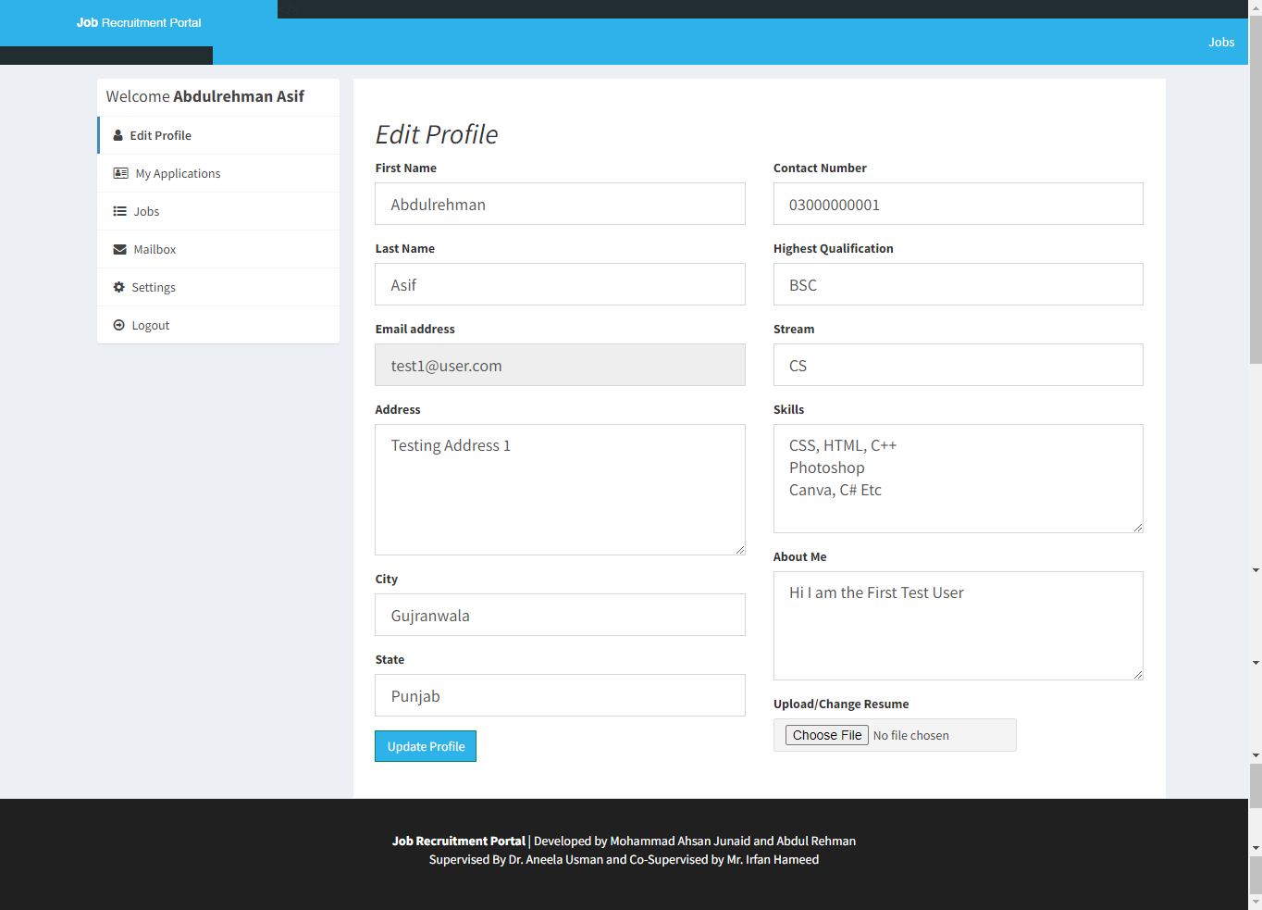

Figure 4. 9

### Applicant Dashboard – Job Applications

The following features would be displayed on the page's output:

* Navigation: The page has a header section with a navigation menu and a logo. Users can access various website sections, including the list of vacant positions, using the navigation menu.
* User Profile Sidebar: The user's name and links to several profile-related actions, such as editing their profile, accessing their mailbox, and changing settings, are displayed in the sidebar on the left side of the page.
* Recent Applications: A list of the user's most recent job applications is displayed in the page's main content area. The job title, application date, and application status are all displayed for each application. A detailed view of the job posting can be accessed by clicking the job title.

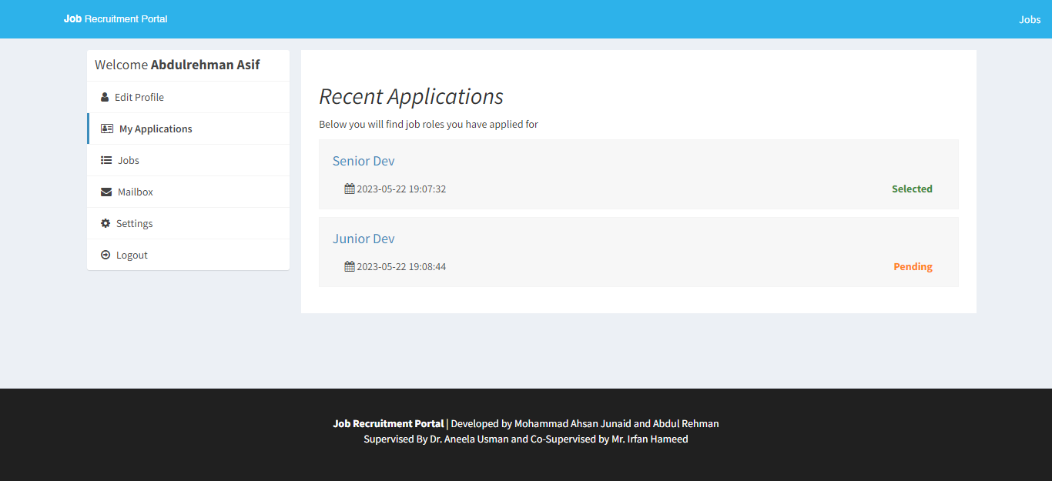

Figure 4. 10

### Applicant Dashboard – Mailbox

The following features would be displayed on the page's output:

* Mailbox Section: The "Mailbox" section is the page's primary content. For the logged-in user, it shows a list of messages that have been received and sent. Each message's subject and date are displayed on screen. The user can access the entire message's content by clicking the link in the subject.
* Create New Message: The "Create" button, which enables users to write new messages.
* Navigation: Links to the portal's various sections, including "Jobs."
* Sidebar: Features a list of choices for the user who is logged in in the sidebar. There are several options available, including "Edit Profile," "My Applications," "Jobs," "Mailbox," "Settings," and "Logout." This makes it simple to access the portal's various features.

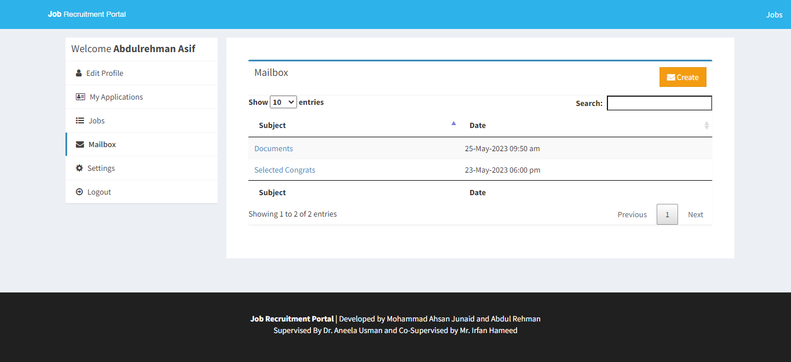

Figure 4. 11

### Applicant Dashboard – Read / Reply Mail

The following features would be displayed on the page's output:

* Form for Writing a New Message:   
  On the output page, there is a form for writing a new message. The form has sections for writing the message body, selecting the recipient from a list of companies, and entering the subject. It has fields for choosing the recipient, writing the message body, and choosing a subject.
* Menu of Options:   
  A menu of options is visible on the output page, including "Edit Profile," "My Applications," "Mailbox," "Settings," and "Logout." These choices enable users to carry out a variety of tasks within the portal.

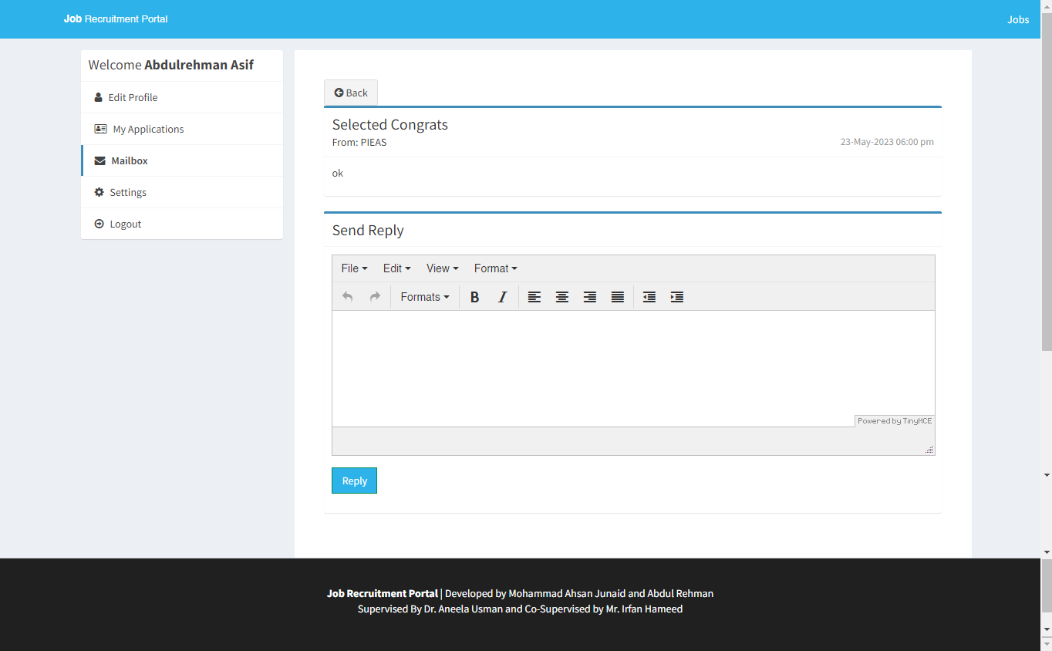

Figure 4. 12

### Applicant Dashboard – Settings

The following features would be displayed on the page's output:

* Change Password Form:   
  The form for changing the user's password is located in the page's main content area. It has two input fields where the new password can be entered and confirmed. Additionally, there is a submit button marked "Change Password." The password and confirm password fields must match for the form to be valid.
* Deactivate Account Form:   
  There is a form to deactivate a user's account. It has a checkbox to confirm the user's desire to deactivate the account and a "Deactivate My Account" submit button.
* The page has a navigation bar at the top that users can use to access the different website sections. In this instance, a link to "Jobs" is available.
* User Profile Sidebar:   
  A sidebar on the left of the page contains details about the user who is currently logged in. Links to various actions, including editing the profile, viewing applications, accessing the mailbox, and managing settings are provided, along with the user's name.

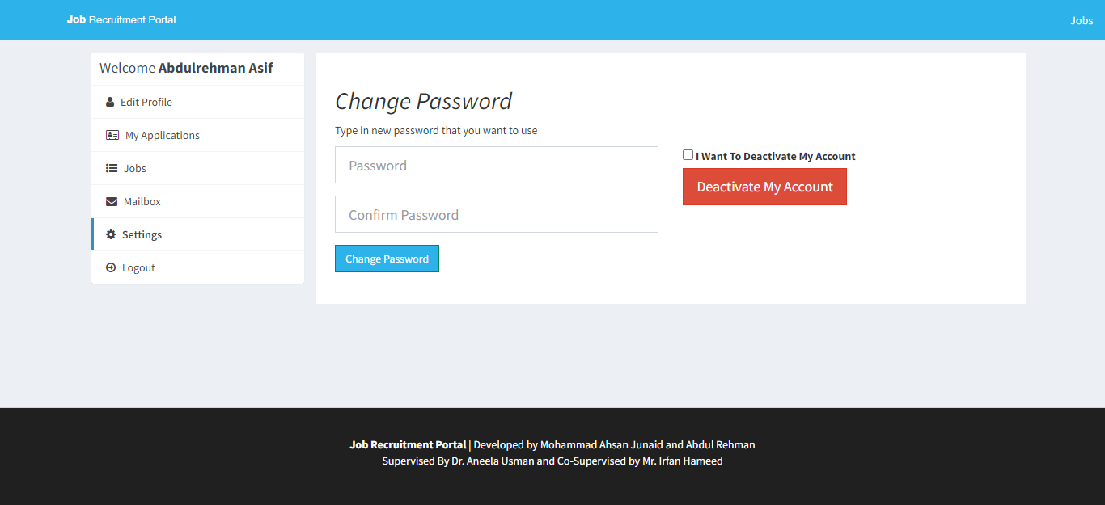

Figure 4. 13

### Employer Dashboard

The following features would be displayed on the page's output:

* Overview Section:   
  The overview section of the page's main content area includes a brief overview of the dashboard. It also has an information icon and an alert message.
* Information Boxes:   
  There are two information boxes below the overview section. The number of job postings created by the user's company is shown in the first box. The quantity of job applications for the company's open positions is displayed in the second box. Using SQL queries, the data in these boxes is retrieved from the database.
* User Profile Sidebar:   
  There is a sidebar on the left side of the page that features the name of the currently logged-in user and links to various account sections.

In general, the output page acts as a dashboard for users of the job recruitment portal who are logged in. It gives users a quick look at their account information, gives them access to different sections, and lets them take actions regarding their business, job postings, job applications, mailbox, and settings.

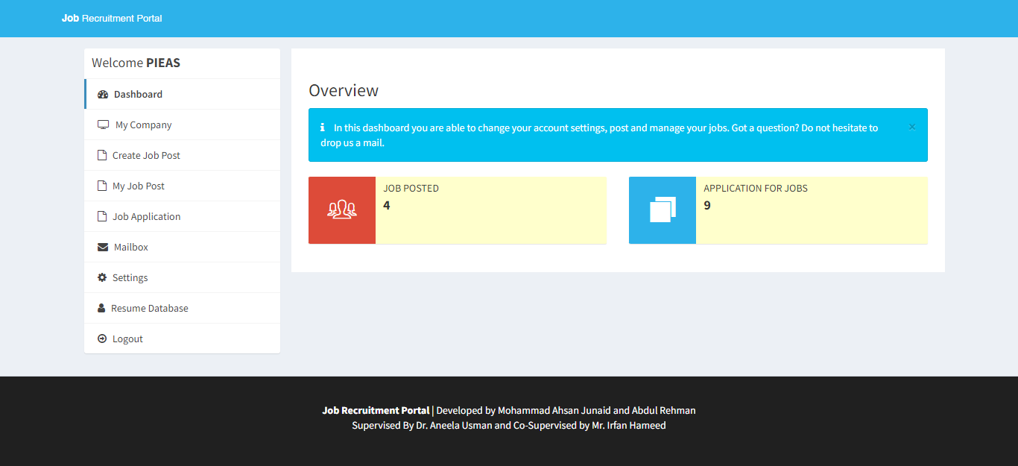

Figure 4. 14

### Employer Dashboard – Company Details Page

The following features would be displayed on the page's output:

* It includes a form for updating company information.
* Company name, website, email, about me, phone number, city, and state are among the fields on the form.
* The form fields have already been filled in with the user's current company information.
* By choosing a file, the user can update the company logo.
* The form is displayed along with the user's uploaded logo, if any.
* An error message is shown below the form if there is a problem with the file upload process.
* Sidebar: The sidebar offers the user a menu with various options.

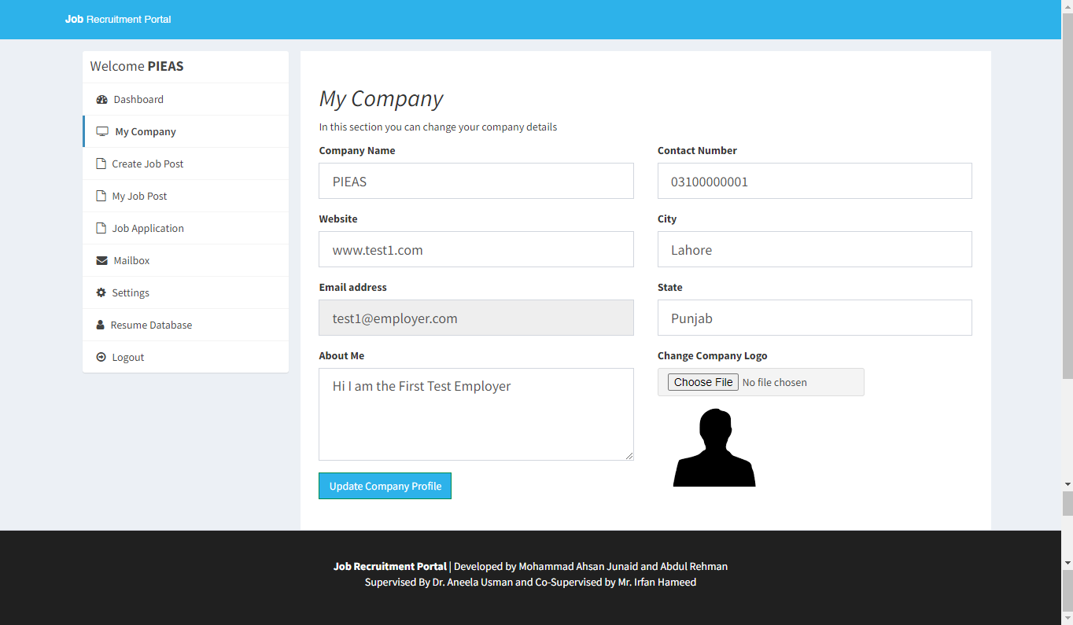

Figure 4. 15

### Employer Dashboard – Create Job Page

The following features would be displayed on the page's output:

* Job description, minimum and maximum salaries, experience and education requirements, and the required maximum age are among the form's fields.
* The user can fill out the relevant form fields with the information for the job posting.
* The information is sent for processing after the form has been submitted. A form for creating a new job posting is included.
* The form's fields for the job title, job description, minimum and maximum salaries, experience and education requirements, and the required maximum age are all included.

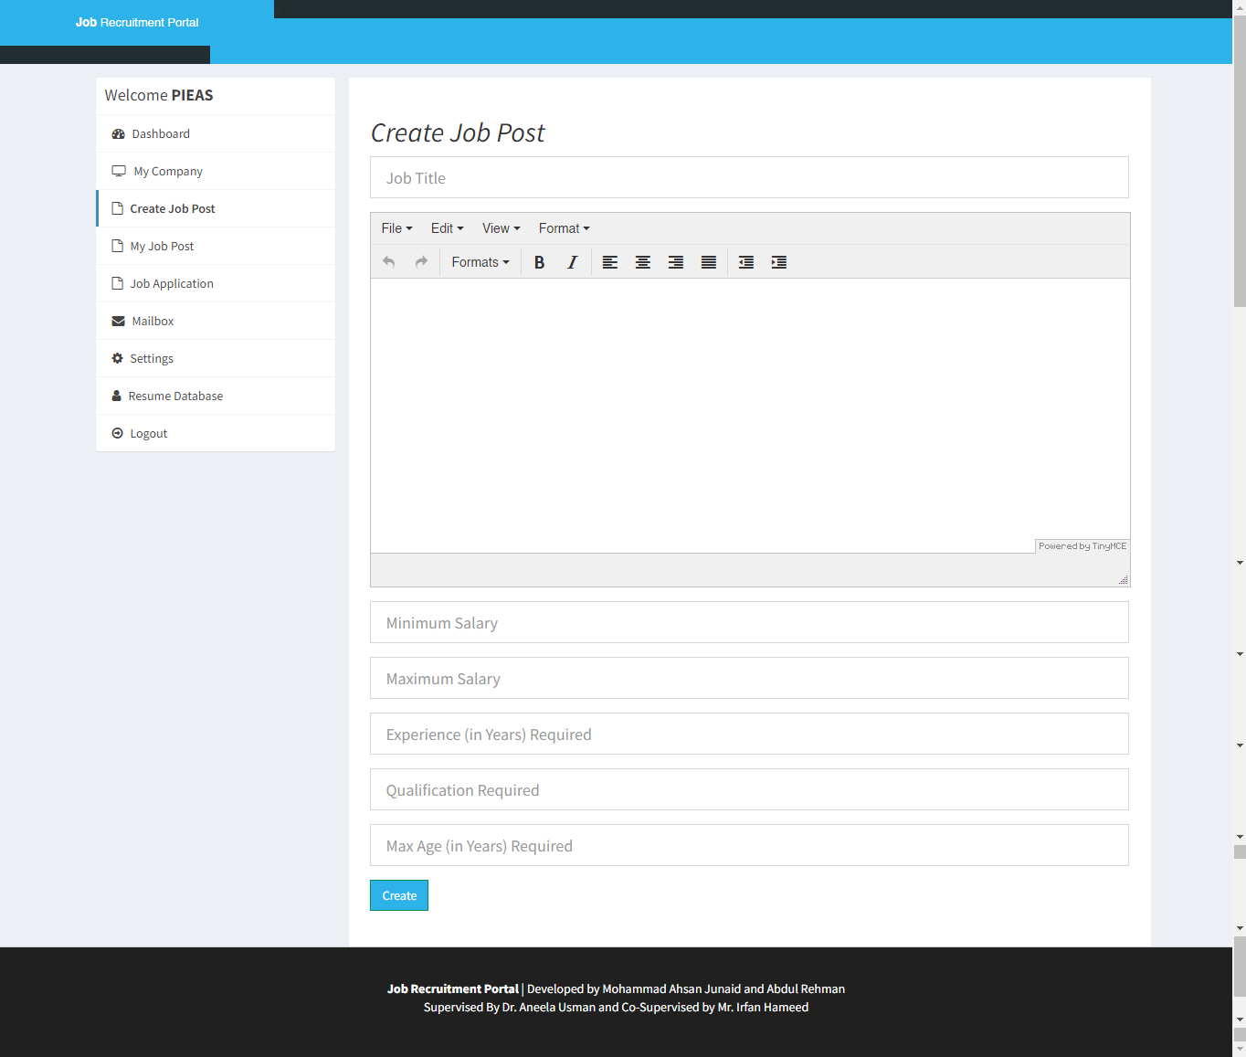

Figure 4. 16

### Employer Dashboard – Posted Jobs

The following features would be displayed on the page's output:

* This shows a table of the user-created job postings.
* Each job post's title is listed in the table, along with a link to view more information.
* Based on the user's company ID, the database's job postings are retrieved.
* The table includes any open positions if there are any.

Generally speaking, the page offers employers a user-friendly interface for viewing and managing their job posts in the job recruitment portal. In order to retrieve and present pertinent information, it provides navigation, data presentation, and integration with a backend database.

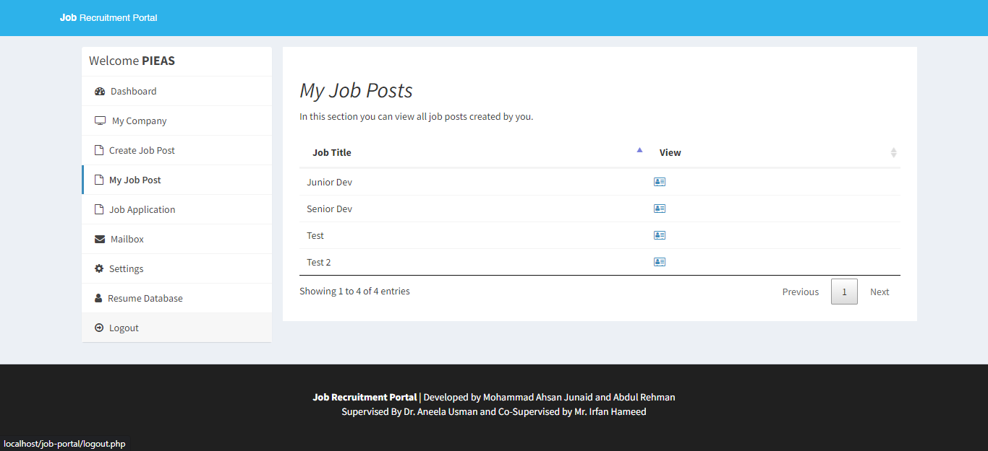

Figure 4. 17

### Employer Dashboard – Job Applications Page

The following features would be displayed on the page's output:

* Recent Applications:   
  The page fetches data from the database about job applications submitted by users. It retrieves the job title, applicant name, application date, and status for each application.
* Application Status:   
  The status of each job application is indicated using different colors or text styles. The possible statuses are "Pending," "Rejected," or "Selected."
* Sidebar: The page has a sidebar on the left side, which displays a list of menu items. Each menu item represents a section of the portal and provides links to navigate to those sections.

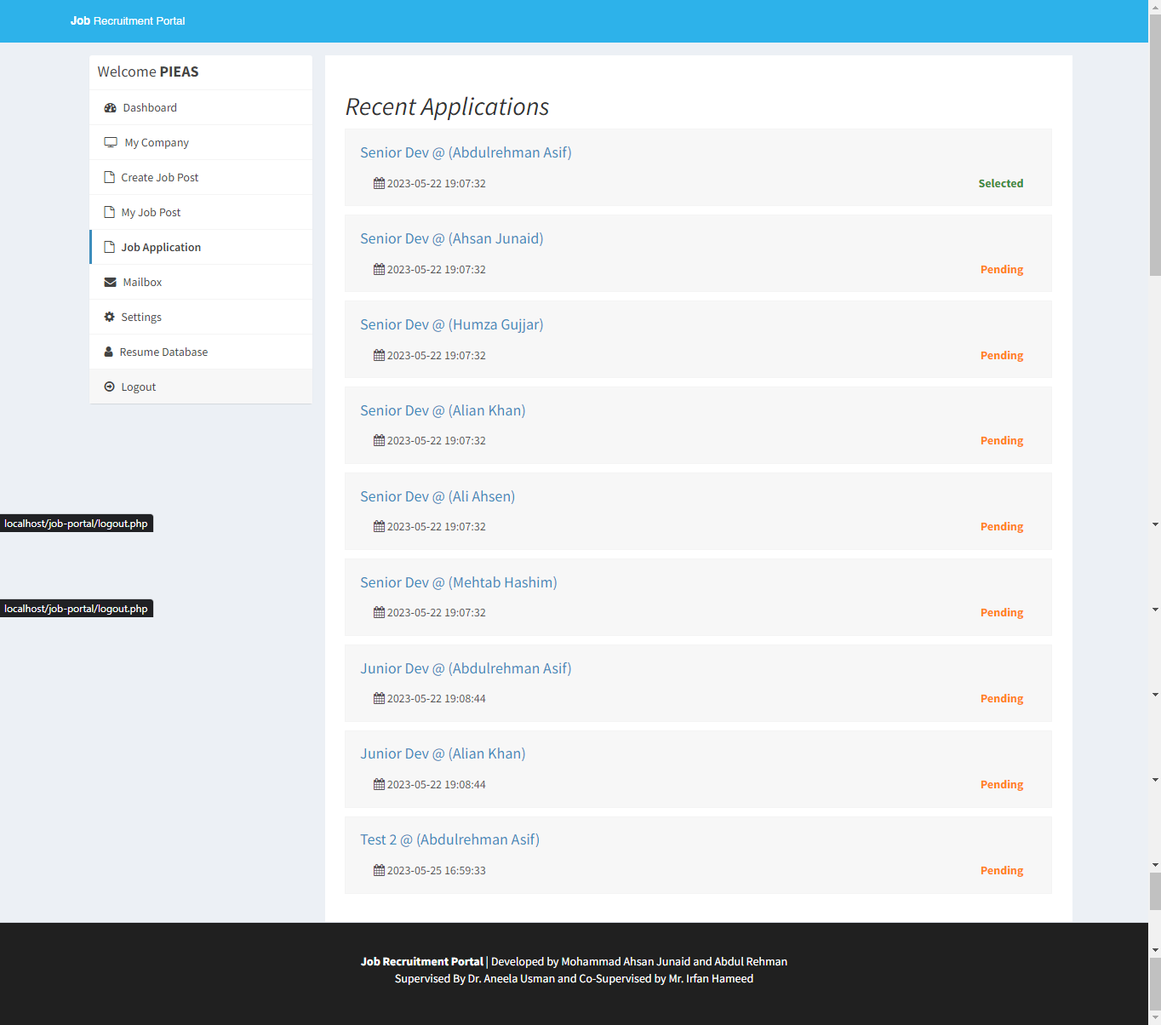

Figure 4. 18

### Employer Dashboard – Mailbox

The following features would be displayed on the page's output:

* Mailbox Section:   
  The "Mailbox" section is the page's primary content. For the logged-in employers, it shows a list of messages that have been received and sent. Each message's subject and date are displayed on screen. The employer can access the entire message's content by clicking the link in the subject.
* Create New Message:   
  The "Create" button, which enables users to write new messages.
* Sidebar:   
  Features a list of choices for the user who is logged in in the sidebar. There are several options available, including "Edit Profile," "My Applications," "Jobs," "Mailbox," "Settings," and "Logout," etc. This makes it simple to access the portal's various features.

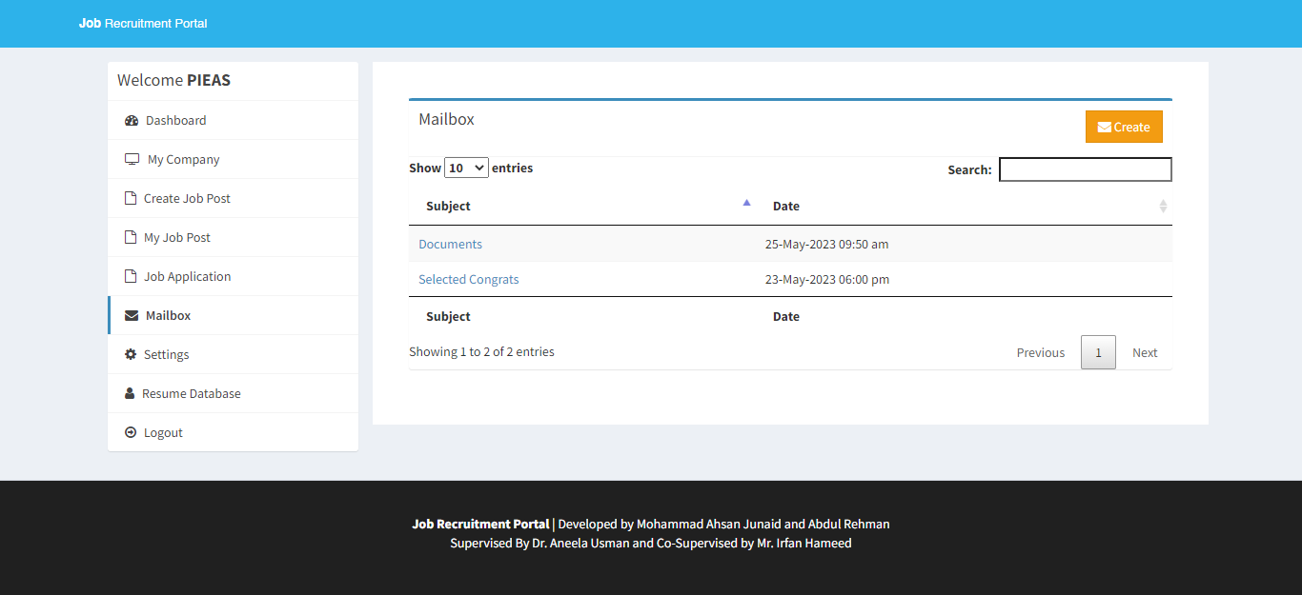

Figure 4. 19

### Employer Dashboard – Reply / Create Mail Page

The following features would be displayed on the page's output:

* Form for Writing a New Message:  
  There is a form for writing a new message. The form has sections for writing the message body, selecting the recipient from a list of companies, and entering the subject. It has fields for choosing the recipient, writing the message body, and choosing a subject.
* Menu of Options:   
  A menu of options is visible on the output page, including "Edit Profile," "My Applications," "Mailbox," "Settings," and "Logout." These choices enable users to carry out a variety of tasks within the portal.

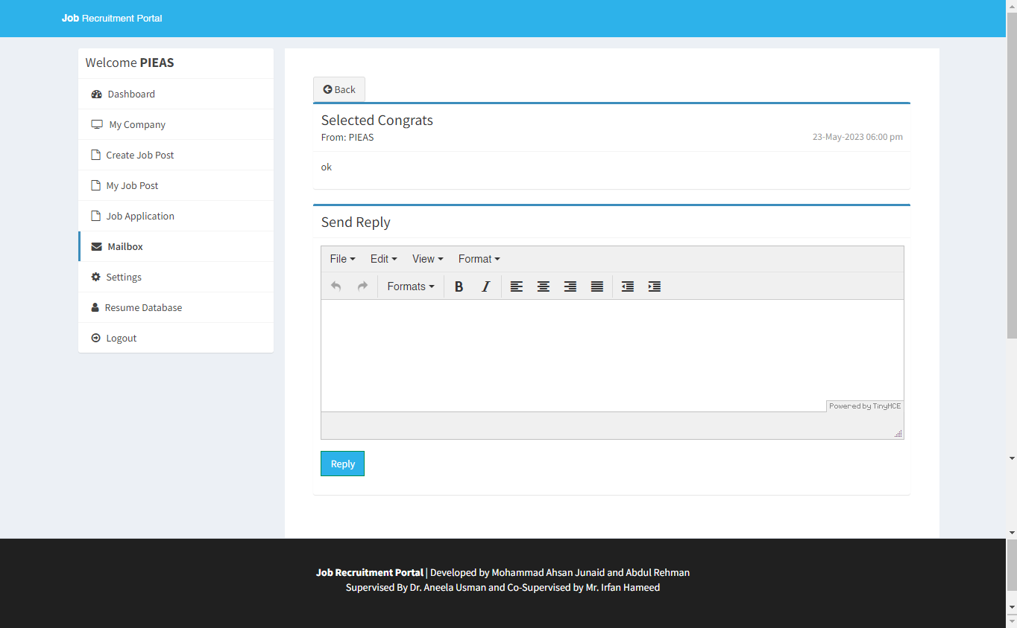

Figure 4. 20

### Employer Dashboard - Settings

The following features would be displayed on the page's output:

* Change Password Form:   
  The form for changing the employer's password is located in the page's main content area. It has two input fields where the new password can be entered and confirmed. Additionally, there is a submit button marked "Change Password." The password and confirm password fields must match for the form to be valid.
* Change Name Form:   
  The form for changing the employer's name is located in the page. It has a input field where the name can be entered and confirmed. Additionally, there is a submit button marked "Change Name".
* Deactivate Account Form:   
  There is a form to deactivate an employer's account. It has a checkbox to confirm the user's desire to deactivate the account and a "Deactivate My Account" submit button.

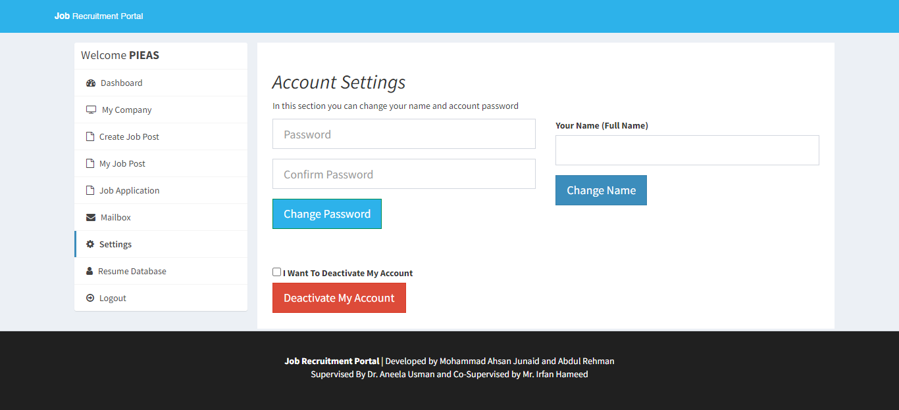

Figure 4. 21

### Employer Dashboard – Applications Database

The following features would be displayed on the page's output:

* Applications Database Table: The page fetches data from the database about job applications submitted by users. It retrieves the candidate's name, highest qualification, age, city, and state for each application.
* Download Resume: Each row in the table includes a "Download Resume" link that allows the user to download the candidate's resume. The link points to the resume file stored in the "uploads/resume" directory.
* Download CSV: The page includes a "Download CSV" button that allows the user to download the application data in CSV format. When clicked, the button retrieves the table data, converts it into a CSV string, and triggers a file download.

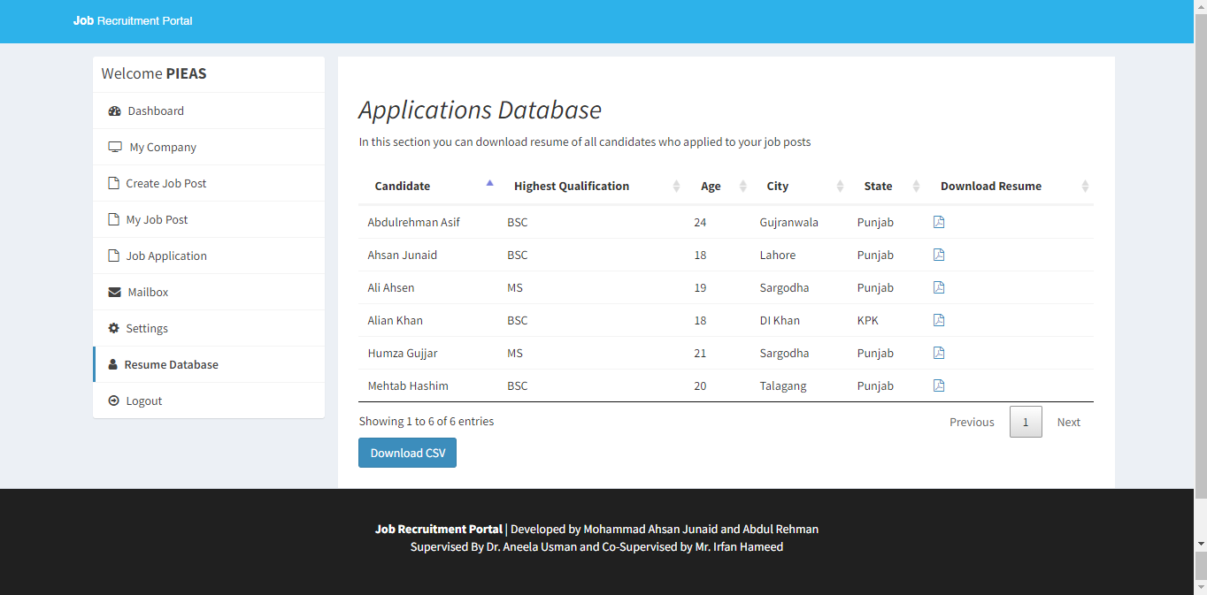

Figure 4. 22

### Admin Dashboard

The following features would be displayed on the page's output:

* The content section of the dashboard displays various statistics related to the job portal, such as the number of active companies, pending company approvals, registered candidates, pending candidate confirmations, total job posts, and total applications.
* Admin dashboard page that displays statistics related to the job portal.
* Sidebar: The sidebar is located on the left side and includes a box with a welcome message and a list of navigation links. The active page is highlighted.

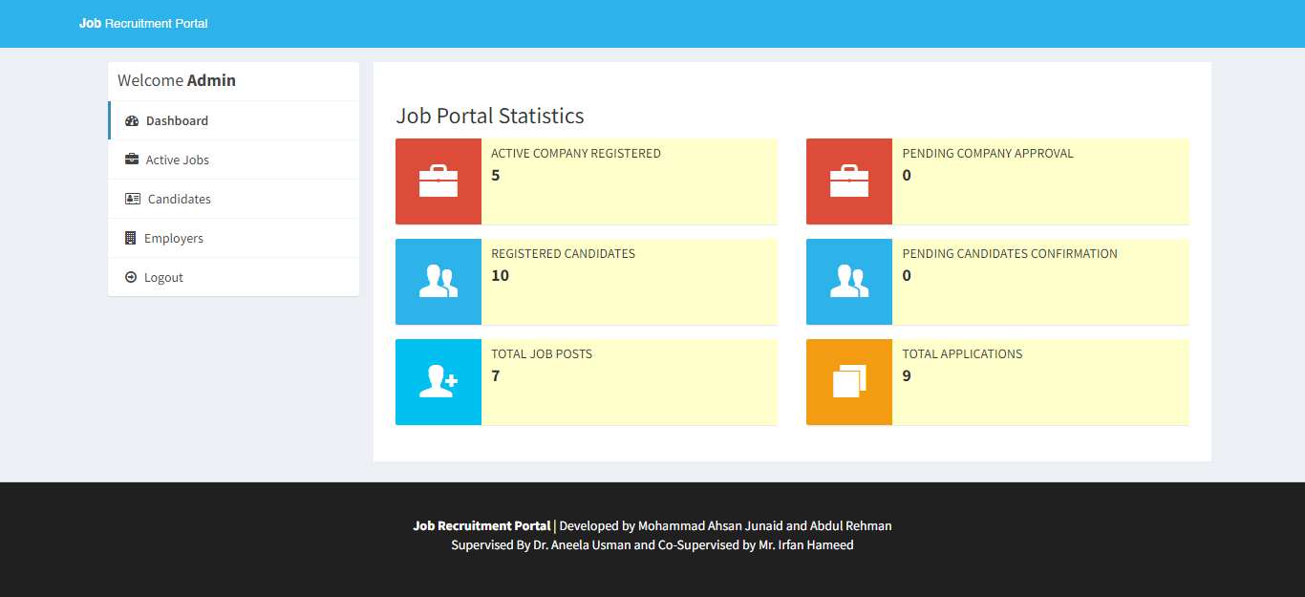

Figure 4. 23

### Admin Dashboard – Active Jobs

The following features would be displayed on the page's output:

* The main content area displays a table of active job posts.
* Each row in the table represents a job post and contains the following information:
* Job Name: The title/name of the job post.
* Company Name: The name of the company associated with the job post.
* Date Created: The date when the job post was created.
* View: An icon/button to view more details about the job post.
* Delete: An icon/button to delete the job post

This page provides an interface for the admin user to view and manage active job posts in the job recruitment portal. The sidebar navigation allows easy access to different sections, and the job posts table provides an organized view of the available job opportunities.

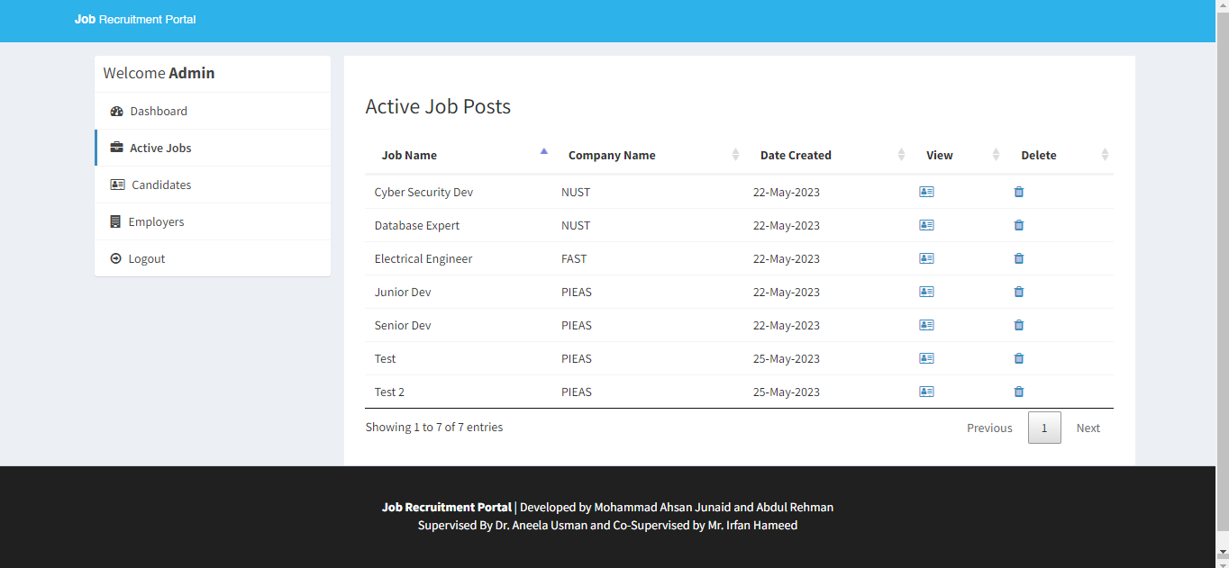

Figure 4. 24

### Admin Dashboard – Applicants Database

It displays a table that lists candidates from a database, providing essential information such as their names, qualifications, skills, location, and resume availability, the following features would be displayed on the page's output:

* Table for Candidate Information: It contains the following columns:
  + Candidate: Displays the candidate's full name.
  + Highest Qualification: Shows the highest qualification of the candidate.
  + Skills: Displays the candidate's skills as labels.
  + City: Shows the city where the candidate is located.
  + State: Displays the state where the candidate is located.
  + Download Resume: Provides a link to download the candidate's resume if available.

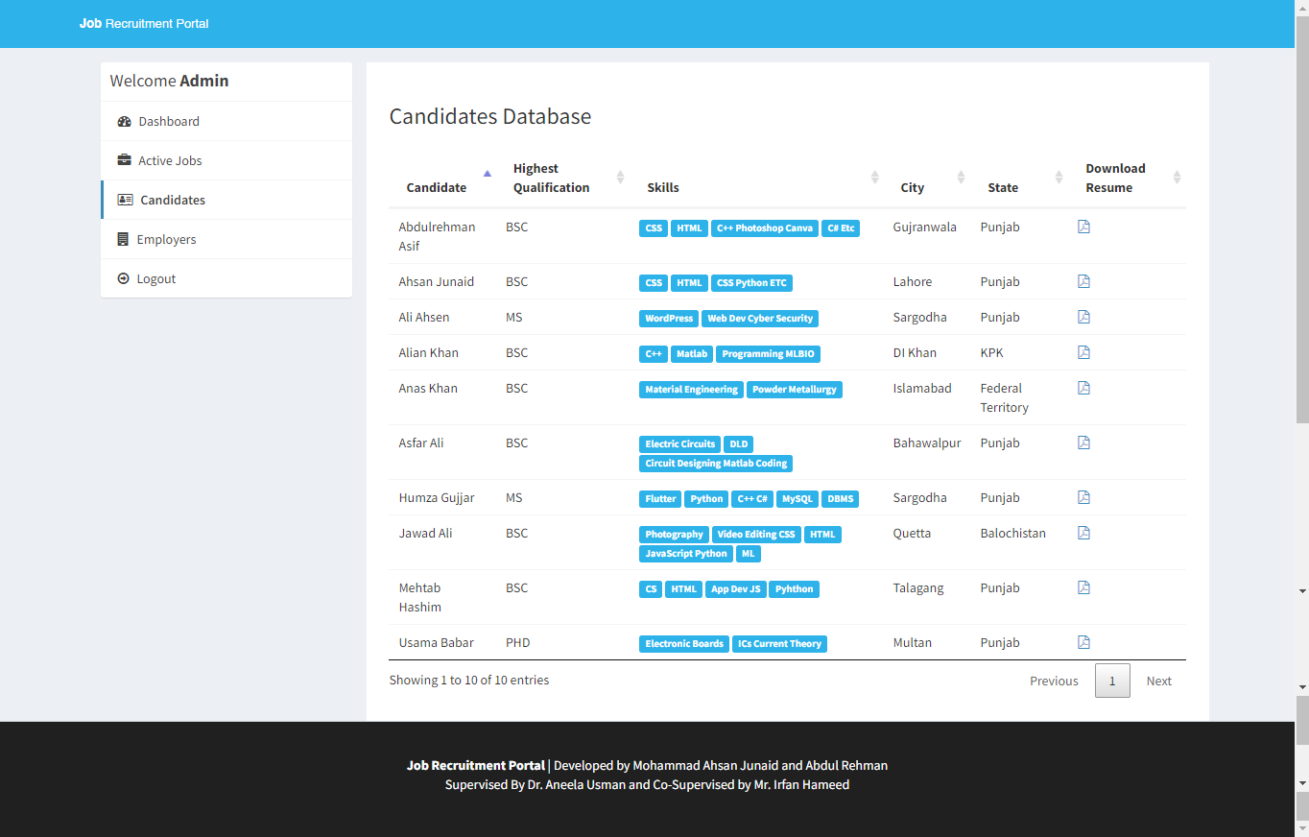

Figure 4. 25

### Admin Dashboard – Employers Database

The following features would be displayed on the page's output:

* Status Management:

The "Status" column in the table indicates the current status of each company. The status can be "Activated," "Rejected," or have options to "Reject," "Approve," or "Reactivate" the company, depending on the active status value.

* Table that lists the company information. The table consists of the following columns:
* Company Name: This column displays the name of the company.
* Account Creator Name: This column shows the name of the admin or user who created the company's account.
* Email: This column displays the email address associated with the company.
* Phone: This column shows the phone number of the company.
* City: This column displays the city where the company is located.
* State: This column shows the state or region where the company is located.
* Country: This column displays the country where the company is located.
* Status: This column indicates the current status of the company. The status can be "Activated," "Rejected," or have options to "Reject," "Approve," or "Reactivate" the company, depending on the active status value.
* Delete: This column includes a link or button that allows the admin to delete the company entry from the database.

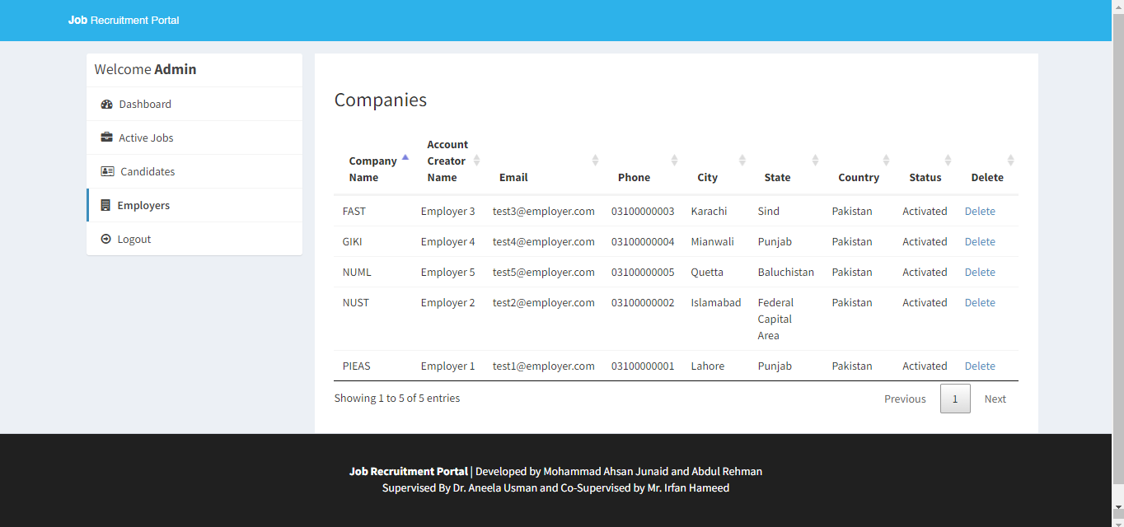

Figure 4. 26

## Backend Development

### How to Calculate Workload?

Workload calculation was one of the challenging tasks as there was no previous system in the institute that calculates workloads of its employees. Moreover, there are several factors that can contribute in workload so how to tackle them and bring into an automated system was also a big challenge for me. For this, a formula was derived to calculate workload’s final score.

Final Score = [Factor 1*wFactor 1] + [Factor 2*wFactor 2] + [Factor 3*wFactor 3] & so on... where

* + - 1. Factor is the value that user types in the workload form.
      2. wFactor is the weight of a particular factor.

### How to Handle Workload Weights?

Each factor of the workload contains its weight. So, if the weights of factors are set static, it becomes a hectic task to change the weight of a factor repeatedly because there may come a need in future to alter any of the weights.

In order to tackle this situation, a configuration page is developed where all the weightage parameters can be updated.

## Database Structure

The following tables make up the database of the system:

* + 1. admin: Keeps track of the administrators or system administrators who oversee the job portal.
    2. apply_job_post: Keeps track of the applications that job seekers send in for particular job postings. Fields like the application ID, job post ID, user ID etc. are in it.
    3. cities: Lists the cities or places that can be connected to user profiles or job postings.
    4. company: Saves information about businesses or employers, such as the company ID, name, contact details, and other pertinent business-specific information.
    5. countries: Saves a list of nations that can be referred to geographically in user profiles or job postings.
    6. job_post: Maintains data on job postings made by employers. Details like the job post ID, company ID, job title, description, qualifications, and application details are included.
    7. mailbox: Controls user communication, including that between employers and job seekers. It keeps track of messages as well as sender and receiver information.
    8. reply_mailbox: Holds responses to messages delivered via the mailbox. It contains fields like the message ID, the sender ID, the receiver ID, the content of the reply.
    9. states: Especially in countries with subdivisions, this section contains a list of states or regions that can be connected to job postings or user profiles.
    10. users: Saves user data, including that of employers and job seekers. It has fields for user ID, name, email, password, and contact information so on.

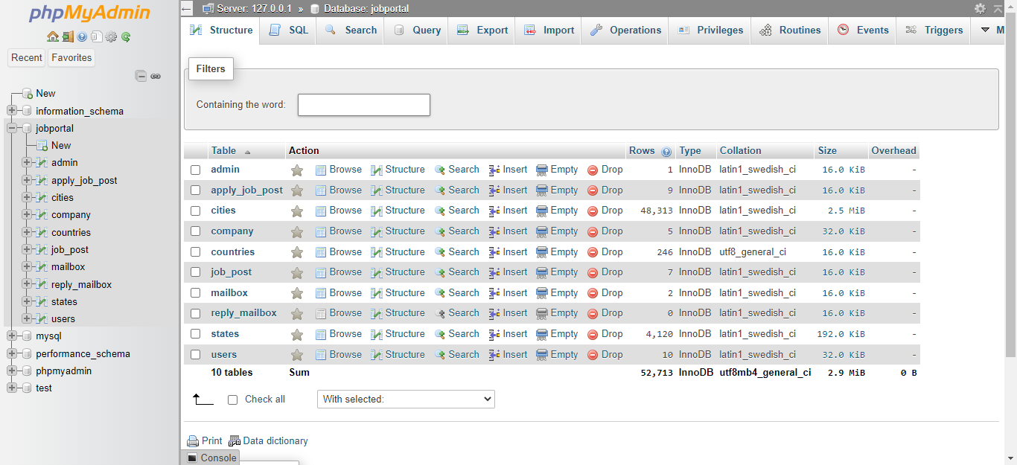

Figure 4. 27

### Admin Table

Description of each column in the table:

* + - 1. id_admin: It represents the unique identifier for each admin in the table.
      2. username: It stores the username or login name of the admin.
      3. password: It stores the encrypted password associated with the admin's account.

These columns store the essential information related to the admin accounts in the table, allowing for proper identification and authentication of administrators within the system.

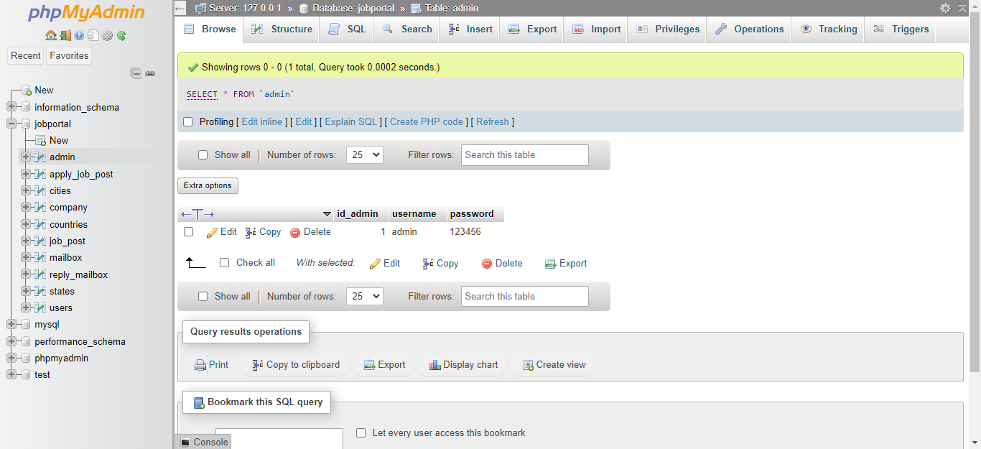

Figure 4. 28

### Apply_Job Table

Description of each column in the table:

* + - 1. id_apply: It represents the unique identifier for each job application in the table.
      2. id_jobpost: It stores the identifier of the job post to which the application is made.
      3. id_company: It stores the identifier of the company associated with the job post.
      4. id_user: It stores the identifier of the user or candidate who submitted the application.
      5. status: It represents the status of the job application, indicating whether it is pending, approved, rejected, or any other relevant status.

These columns are used to manage and track job applications, associating them with specific job posts, companies, and users, and keeping track of their status throughout the application process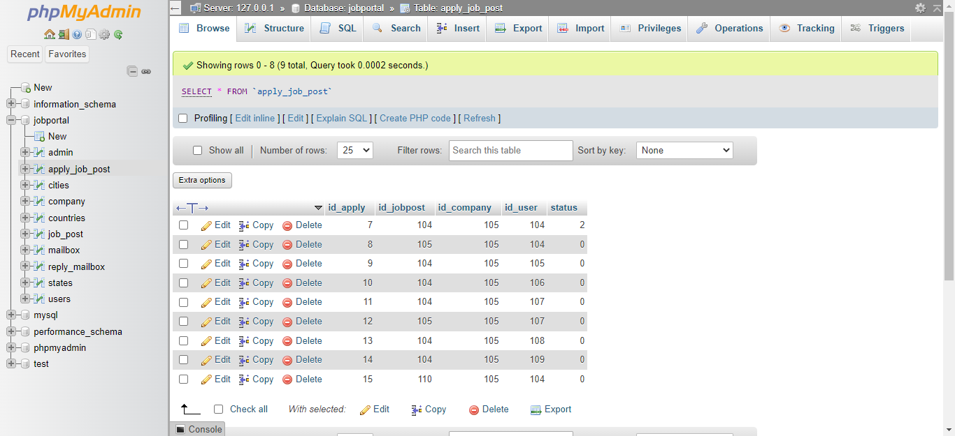

Figure 4. 29

### Cities Table

The table "cities" represents a collection of cities. Here's a brief description of each column:

1. id: It is a unique identifier for each city in the table.

2. name: It stores the name of the city.

3. state_id: It represents the identifier of the state to which the city belongs. This column establishes a relationship with the "states" table, where states are defined.

The "cities" table allows for the storage and retrieval of city-related data.

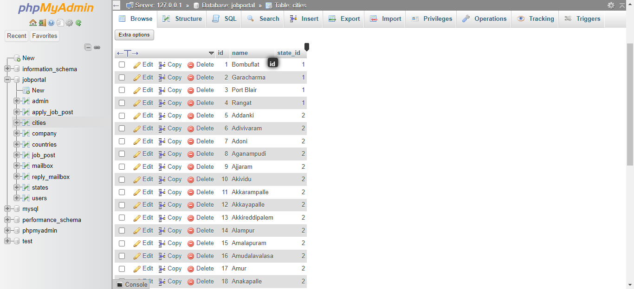

Figure 4. 30

### Companies Table

The table "id_company" represents a collection of employers. Description of each column:

1. id_company: It is a unique identifier for each company in the table.

2. name: It stores the name of the contact person or account creator associated with the company.

3. companyname: It represents the name of the company.

4. country: It stores the country where the company is located.

5. state: It represents the state or province where the company is located.

6. city: It stores the city where the company is located.

7. contactno: It stores the phone number associated with the company.

8. website: It represents the website URL of the company.

9. email: It stores the email address associated with the company.

10. password: It stores the password for the company's account.

11. aboutme: It provides a description or information about the company.

12. logo: It stores the file or path of the company's logo.

13. createdAt: It indicates the date and time when the company's account was created.

14. active: It represents the status of the company's account (e.g., activated, rejected, pending, etc.).

The "id_company" table allows for the storage and management of company-related information. It can be used in a job recruitment portal to store details about employers, their contact information, and the status of their accounts.

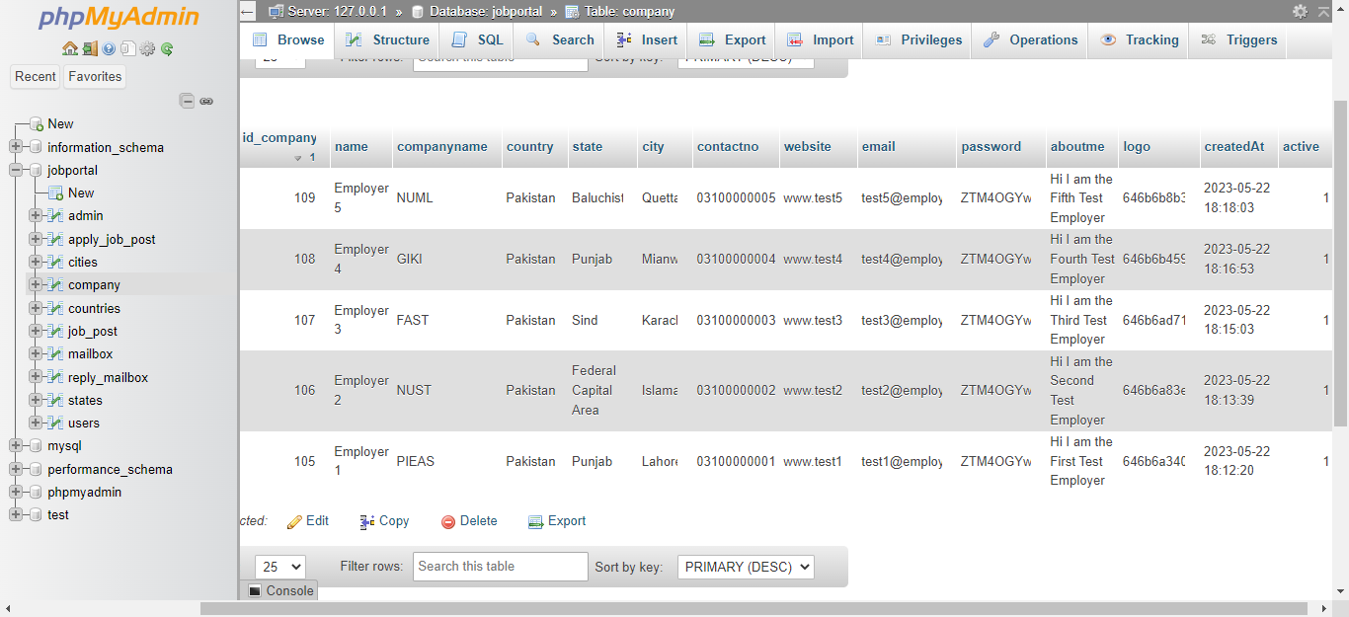

Figure 4. 31

### Countries Table

The table "country" represents a collection of countries. Here's a brief description of each column:

1. id: It is a unique identifier for each country in the table.

2. sortname: It stores the abbreviation or short name of the country.

3. name: It represents the full name of the country.

4. phonecode: It stores the international phone code or dialing code associated with the country.

The "country" table allows for the storage and retrieval of country-related information. It can be used in various applications or systems where country data is required, such as address forms, user profiles, or international phone number validation.

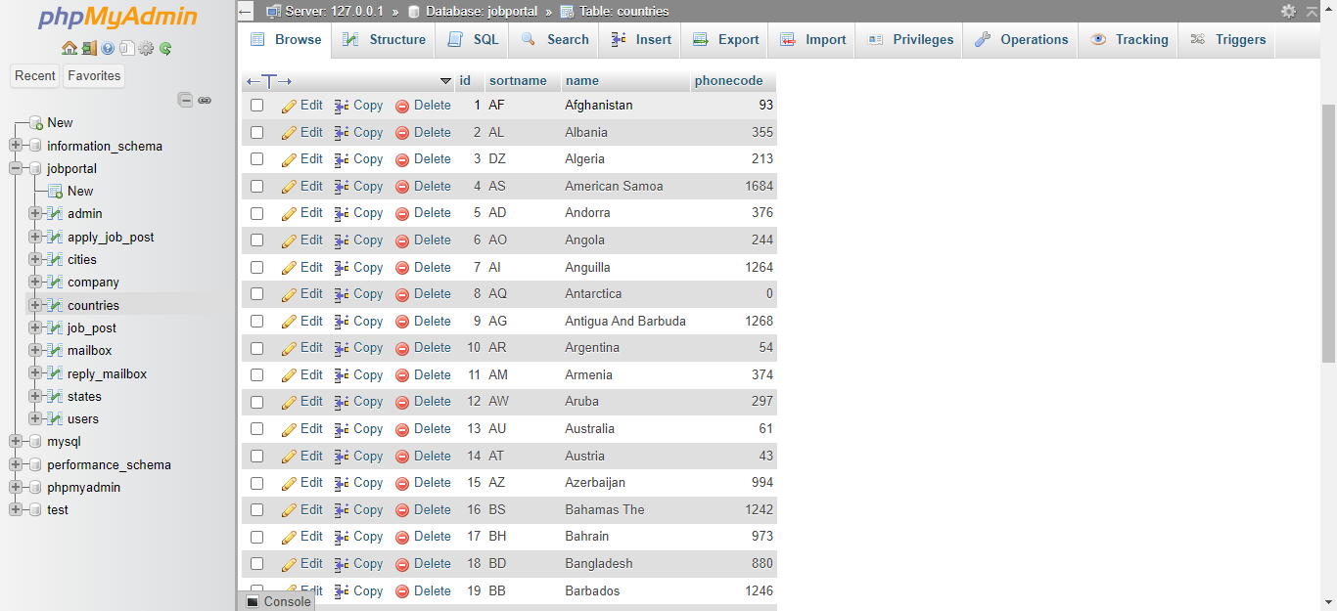

Figure 4. 32

### Job Post Table

The table "jobpost" contains information about job postings. Here's a description of each column:

1. id_jobpost: It is a unique identifier for each job posting in the table.

2. id_company: It represents the foreign key referencing the id of the company that posted the job.

3. jobtitle: It stores the title or name of the job.

4. description: It contains the description or details of the job.

5. minimumsalary: It specifies the minimum salary or salary range for the job.

6. maximumsalary: It represents the maximum salary or salary range for the job.

7. experience: It indicates the required experience level or years of experience for the job.

8. qualification: It stores the required qualifications or educational requirements for the job.

9. createdat: It denotes the timestamp or date when the job posting was created.

10. maxage: It represents the maximum age limit or age restriction for applicants of the job.

The "jobpost" table allows storing and managing job postings, including their titles, descriptions, requirements, and other relevant details. It facilitates the process of job search and recruitment in a system or application.

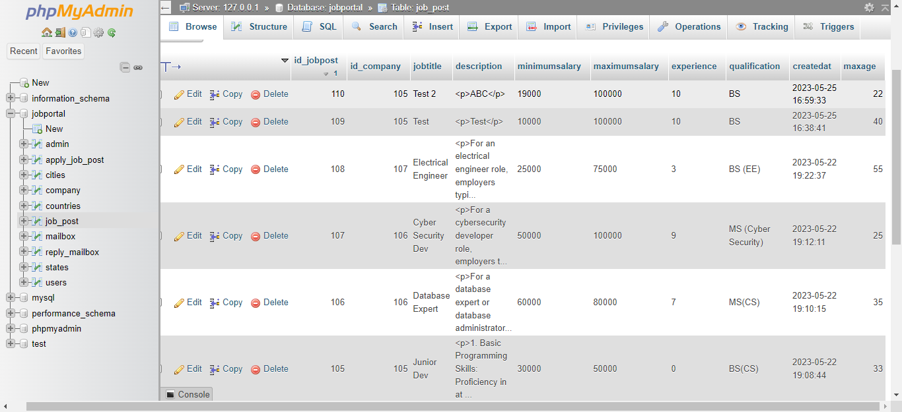

Figure 4. 33

### Mailbox Table

The table "mailbox" contains information related to user messages or emails. Here's a description of each column:

1. id_mailbox: It is a unique identifier for each message or email in the table.

2. id_fromuser: It represents the foreign key referencing the id of the user who sent the message.

3. fromuser: It stores the name or username of the user who sent the message.

4. id_touser: It represents the foreign key referencing the id of the user who received the message.

5. subject: It contains the subject or title of the message.

6. message: It stores the content or body of the message.

7. createdAt: It denotes the timestamp or date when the message was created or sent.

The "mailbox" table allows storing and managing user messages, including the sender, recipient, subject, message content, and creation timestamp. It enables communication and messaging functionality within a system or application.

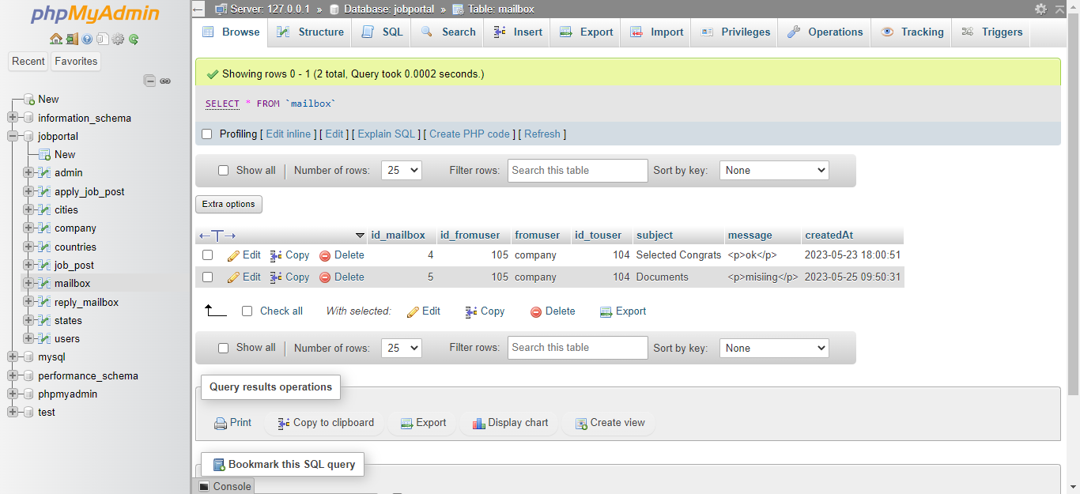

Figure 4. 34

### Reply Mail Table

The table "reply_mailbox" contains information related to the replies or responses to messages in the "mailbox" table. Here's a description of each column:

1. id_reply: It is a unique identifier for each reply in the table.

2. id_mailbox: It represents the foreign key referencing the id of the original message in the "mailbox" table to which the reply belongs.

3. id_user: It represents the foreign key referencing the id of the user who sent the reply.

4. usertype: It indicates the type of user who sent the reply (e.g., admin, customer, etc.).

5. message: It stores the content or body of the reply message.

6. createdAt: It denotes the timestamp or date when the reply was created or sent.

The "reply_mailbox" table allows storing and associating replies with the original messages in the "mailbox" table. It helps maintain a conversation thread or history of communication between users or users and administrators.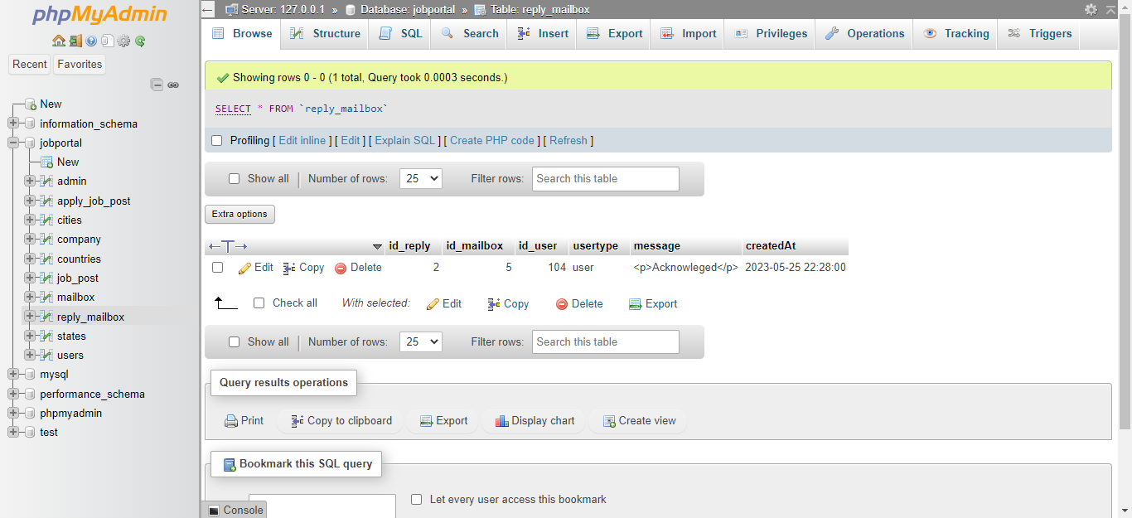

Figure 4. 35

### States Table

The table "states" contains information about states or provinces. Here's a description of each column:

1. id: It is a unique identifier for each state in the table.

2. name: It represents the name of the state.

3. country_id: It represents the foreign key referencing the id of the country to which the state belongs. This column establishes a relationship between states and countries, indicating which country each state is associated with.

The "states" table is typically used to store a list of states or provinces within a country. By linking the states to their respective countries through the country_id column, you can easily retrieve and manage state information based on the country.

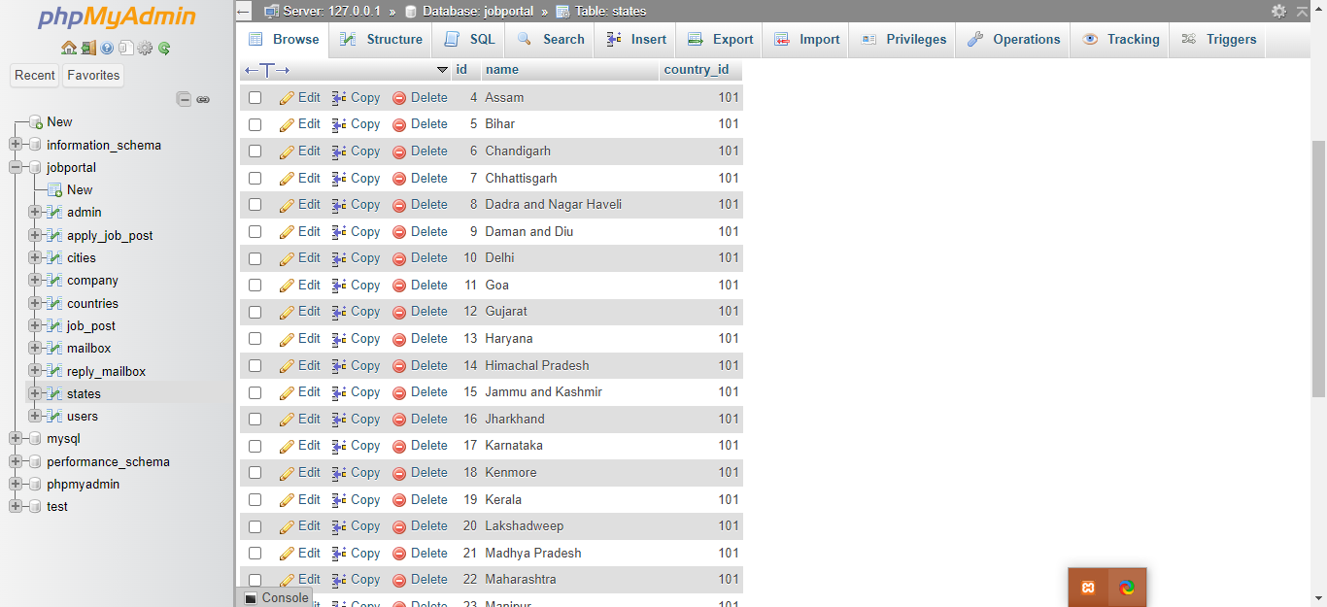

Figure 4. 36

### 4.4.10. Users Table

Brief description of each column in the table:

1. id_user: It represents the unique identifier for each user in the table.

2. firstname: It stores the first name of the user.

3. lastname: It stores the last name of the user.

4. email: It stores the email address of the user.

5. password: It stores the encrypted password associated with the user's account.

6. address: It stores the address of the user.

7. city: It stores the city where the user resides.

8. state: It stores the state or region where the user resides.

9. contactno: It stores the contact number of the user.

10. qualification: It stores the educational qualification of the user.

11. stream: It stores the field or stream of study of the user.

12. passingyear: It stores the year when the user passed their educational qualification.

13. dob: It stores the date of birth of the user.

14. age: It stores the age of the user.

15. cnic: It stores the cnic number of user.

16. resume: It stores the file path or URL of the user's resume or CV.

17. hash: It stores a unique hash value associated with the user's account for security purposes.

18. active: It indicates the activation status of the user's account.

19. aboutme: It stores a brief description or information about the user.

20. skills: It stores the skills or competencies possessed by the user.

These columns collectively store the relevant information about the users in the table, allowing for efficient management and retrieval of user data within the system.

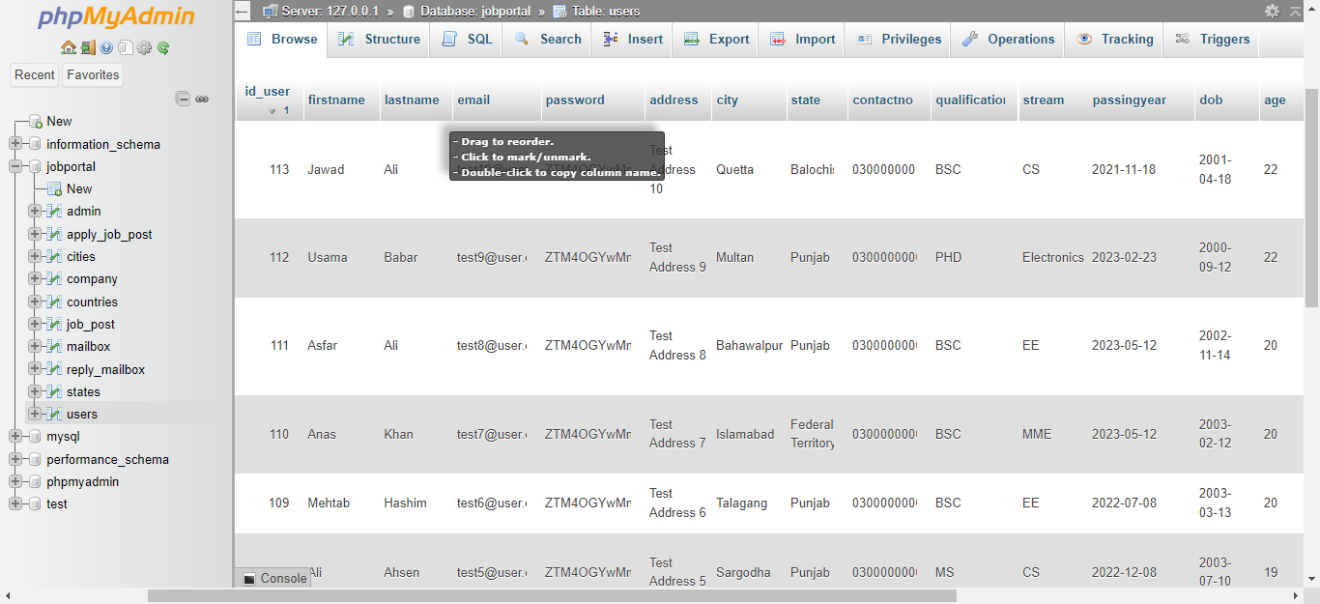

Figure 4. 37

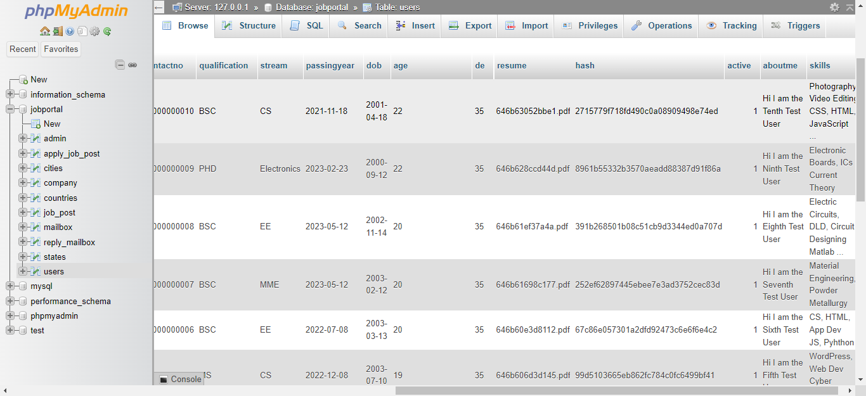

Figure 4. 38

## Web Hosting

A web hosting company called 000webhosting provides both individuals and businesses with cost-free hosting packages. 000webhosting offers users the chance to host their websites for free, making it a desirable option for those looking for hosting services that are affordable.

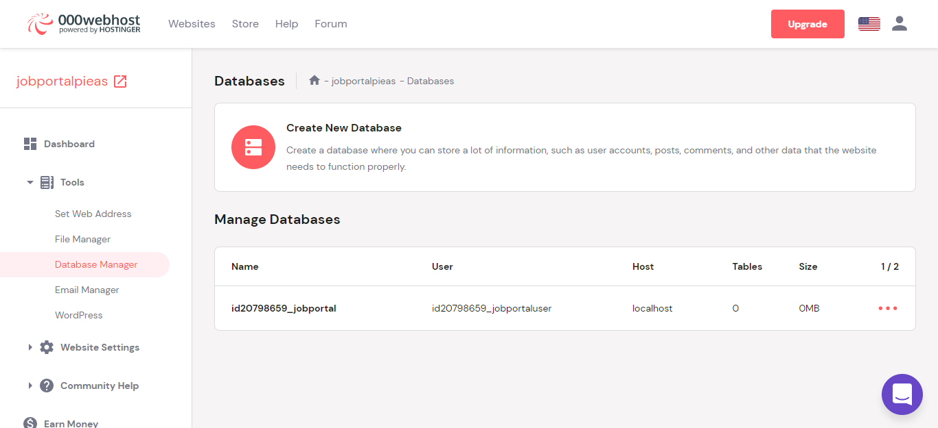

Figure 4. 39

### Backend Management

Users can access a variety of tools and features through 000webhosting's backend management to manage their hosted websites efficiently. Here are some significant components of 000webhosting's backend administration:

* Control Panel: The control panel interface used by 000webhosting enables users to easily navigate and access different management options. Users can manage their hosting preferences, domains, databases, email accounts, and other things using the control panel, which offers a centralized dashboard.
* File Manager: A file manager is a component of the backend administration that enables users to upload, edit, and arrange the files that make up their websites right from the control panel. Users can easily create directories, change file permissions, and operate on files.

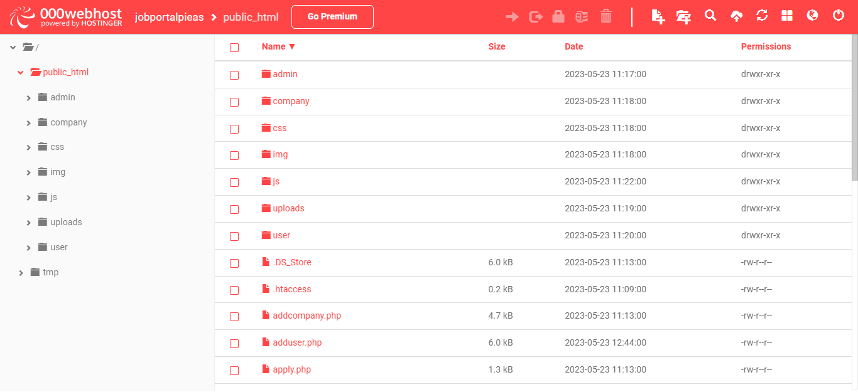

Figure 4. 40

### Database Management

MySQL database management is one of the hosting services provided by 000webhosting. Data can be stored and retrieved using the well-known open-source relational database management system MySQL. A user-friendly MySQL management interface is available to users with 000webhosting, making it easier for them to create, manage, and interact with databases

* Database creation is simple for users and is done right from the hosting control panel. You must enter a database name, username, and password to complete the process. Users can use the newly created database for their content management systems or web applications.
* phpMyAdmin: To interact with MySQL databases, 000webhosting provides phpMyAdmin, a web-based database management tool. It offers a thorough user interface for managing tables, running SQL queries, importing and exporting data, and carrying out various administrative tasks.

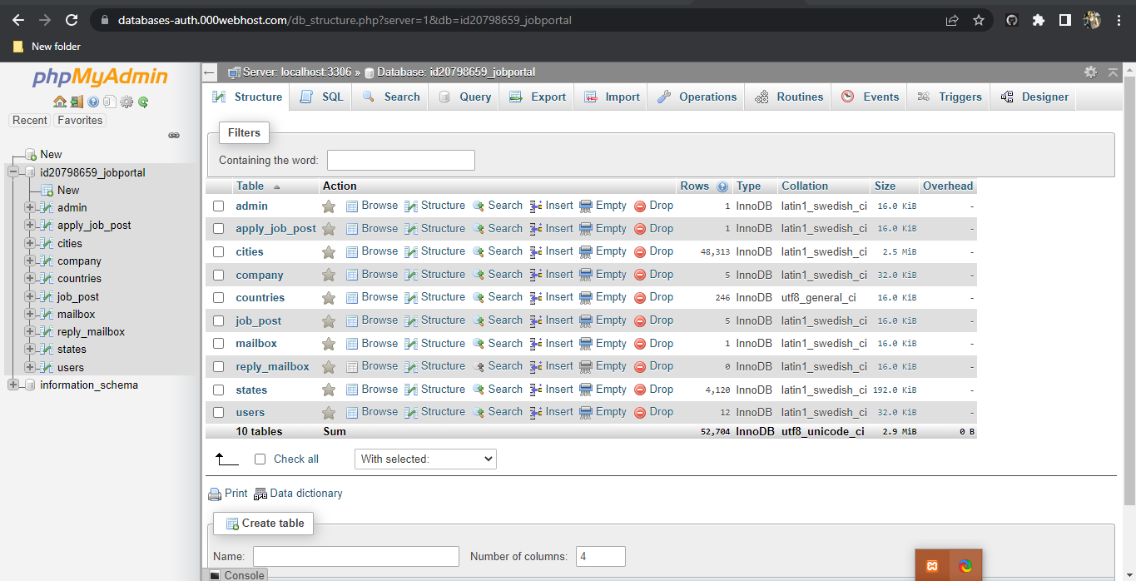Figure 4. 41

# Chapter 5: Structure

## Front End Structural Diagram

The Front End Structure of the system is as following:

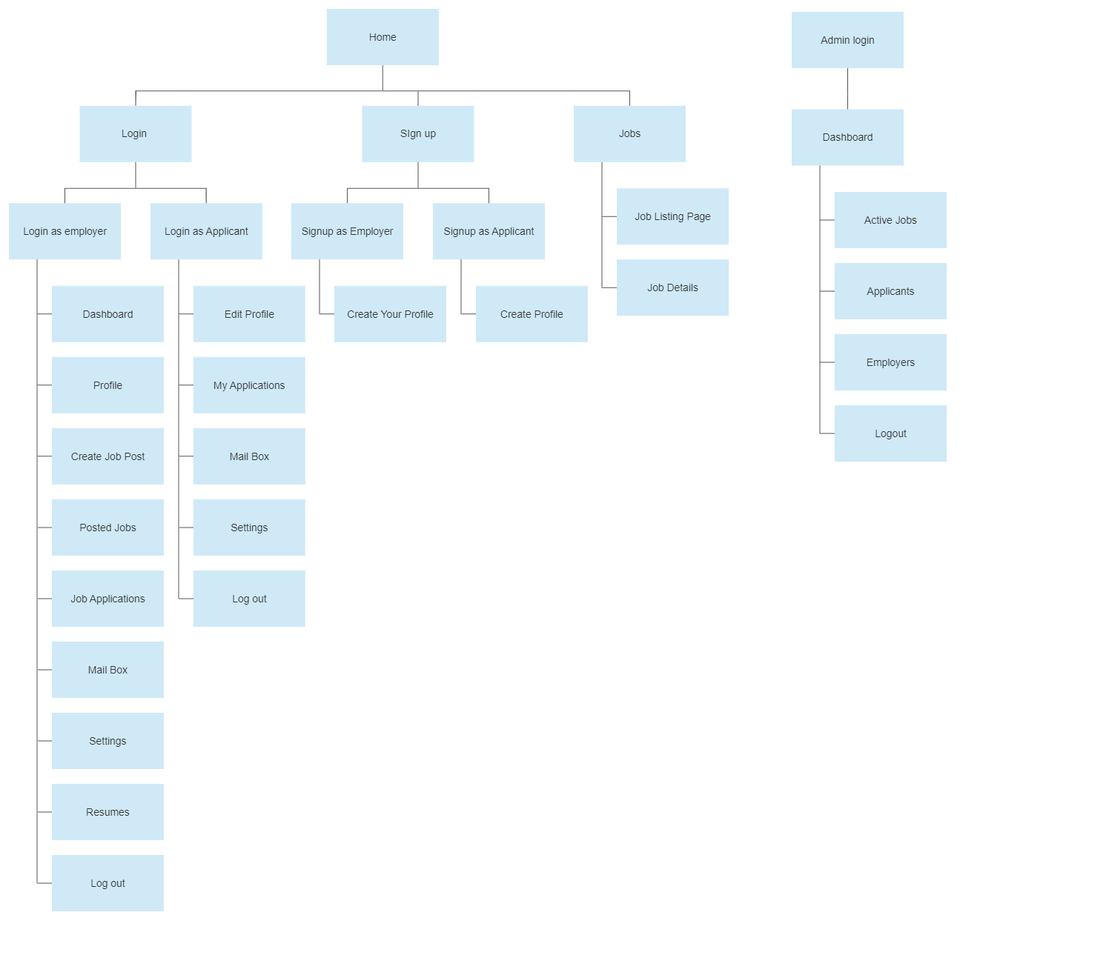Figure 5. 1

## Backend and Database Diagrams

### ER Diagram

The Entity Relation Diagram for the system is as follows:

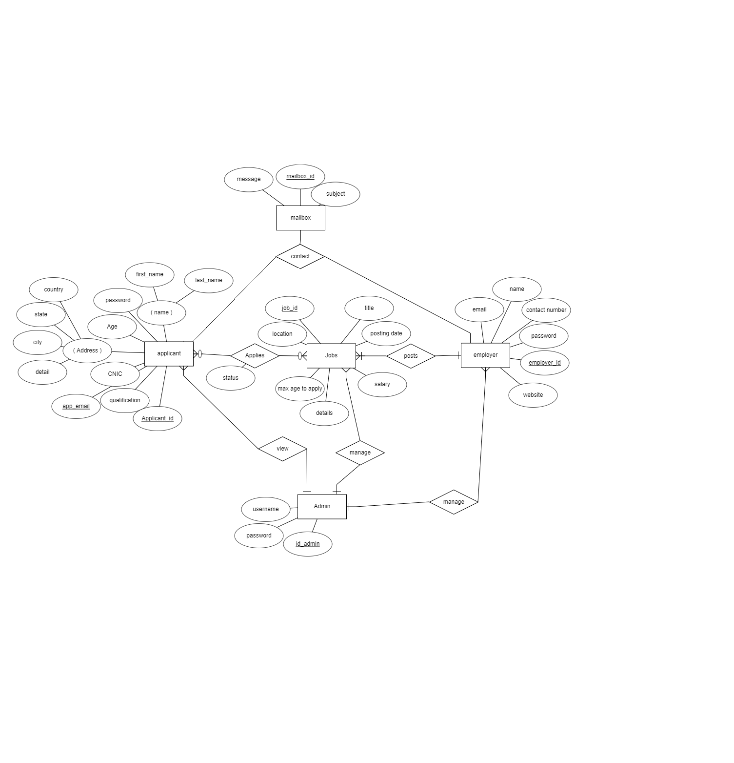Figure 5. 2

### Use Case Diagram

The Use Case Diagram for the system is as follows:

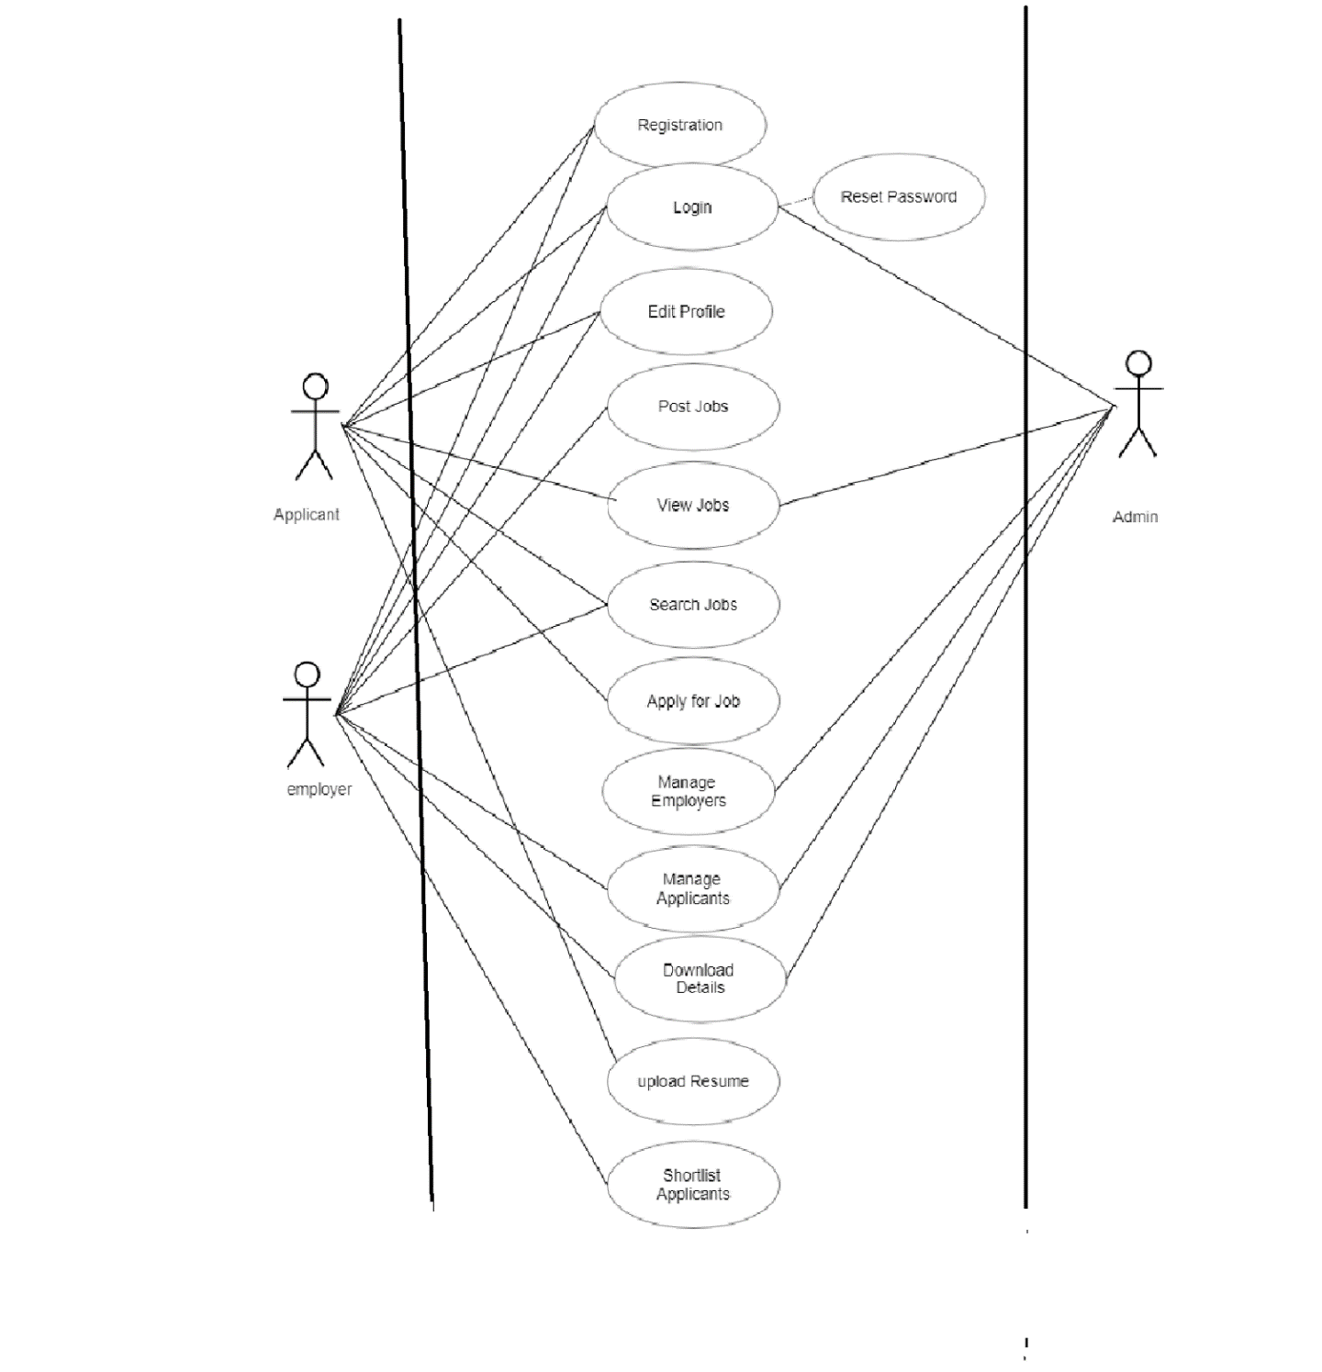

Figure 5. 3

### Context Diagram

The Context Diagram for the system is as follows:

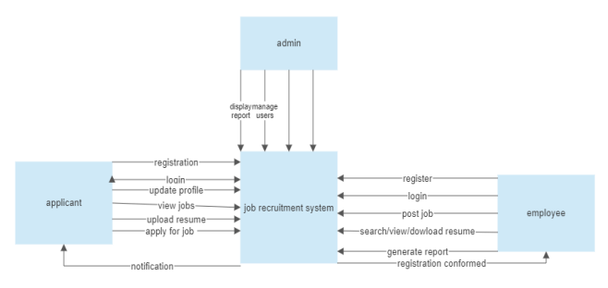

Figure 5. 4

### Relational Schema

The relational schema for this system is as shown below:

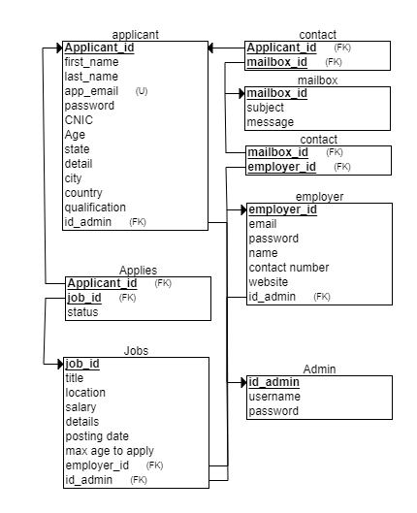

Figure 5. 5

# Chapter 6: User Roles

## . Administrator

As the system administrator and super user for the Job Recruitment Portal, the admin is essential. The management of the portal's general operations is their main duty. Administrators can manage the database, supervise accounts, and uphold system security thanks to their privileged access to the system.

They are able to add, change, or remove accounts, including those for employers. To gain insight into job postings, applications, and user activity, the admin can track the portal's performance, generate reports, and examine system statistics. Administrators may also be able to modify features, set up system preferences, and fix technical problems.

Overall, the administrator's function is crucial to preserving the reliability, security, and effectiveness of the Job Recruitment Portal.

## . Employer

Employers are essential to the Job Recruitment Portal because they are in charge of managing the hiring process and posting job listings. Their main responsibility is to write and post job descriptions that include information about the position's title, requirements, and deadline for applications.

Employers are able to look over and assess applicant profiles, resumes, and other supporting materials. They are able to interact with candidates, plan interviews, and make selections. Additionally, employers may have the power to mark applicants as chosen or rejected for particular job positions.

They can also track the progress of their job postings and applications, as well as download applicant resumes. Employers' primary responsibilities when using the Job Recruitment Portal are to find, evaluate, and hire qualified applicants for their organizations.

## . Applicant / Candidate

Candidates can set up profiles with both personal and professional information, such as their qualifications, training, and experience. They can use filters like job title, location, and keywords to search and browse through the available job listings. In order to decide whether they are qualified for the positions, candidates can review the job descriptions, prerequisites, and application deadlines. Applicants can submit their applications, which ordinarily involve uploading their resumes and other documents, once they locate a desirable job.

During the hiring process, candidates can monitor the progress of their applications, get notifications, and possibly communicate with employers. In the Job Recruitment Portal, applicants' roles are to actively engage in the job search, submit applications for positions that fit their qualifications, and market themselves to prospective employers as qualified candidates.

# Chapter 7: Conclusion and Future Works

## 7.1. Conclusion

The n conclusion, the creation of a job recruitment portal has the potential to revolutionize the hiring procedure, bringing advantages to both employers and candidates. Employers can post job openings, review applicants, and choose qualified candidates on the portal's user-friendly and effective platform. On the other hand, candidates can quickly search for pertinent job openings and easily submit their applications.

To guarantee the effectiveness and success of the portal, various functional and non-functional requirements were taken into account throughout the development process. A scalable, secure, and dependable platform that can support a large number of users while maintaining data integrity was provided by the system architecture. In order to efficiently organize and manage job listings, applicant profiles, and communication records, a database design was carefully created.

The Job Recruitment Portal seeks to minimize the delays, inefficiencies, and missed opportunities frequently connected to conventional recruitment techniques by streamlining the hiring procedure. Employers can save time and effort by reviewing and choosing candidates more quickly, and candidates can easily access a variety of job opportunities and present their qualifications. The intuitive features and user-friendly interface of the portal improve the overall user experience.

The Job Recruitment Portal ensures a reliable and responsive system by integrating technologies like HTML, CSS, MySQL, and suitable frameworks. Key evaluation metrics include performance, usability, and user satisfaction. The results have an impact on the job recruitment industry and offer insightful information for potential future improvements.

Overall, the Job Recruitment Portal is an important tool for bridging the gap between employers and applicants, providing a modern and efficient platform that streamlines the recruitment process and improves the overall experience for all stakeholders. The portal, if successfully implemented, can contribute to increased efficiency, better candidate selection, and increased job opportunities in a competitive job market

## 7.2. Future Works

Future efforts will aim to improve job matching, streamline processes, and make better use of emerging technologies to improve user experience and make the job portal more effective and user-friendly. The potential future works that can be done include adding

### 7.2.1. Live Interviewing:

By incorporating live interviewing features into the job portal, employers will be able to conduct virtual, on-demand interviews with candidates. In order to facilitate remote interviews and remove geographic restrictions, this may include features like video conferencing, chat capabilities, screen sharing, and recording options.

### 7.2.2. Enhanced Search and Filtering:

Users will be able to focus their job searches based on details like location, salary range, job type, experience level, and more by using advanced search and filtering options.

### 7.2.3. Personalized Recommendations:

Creating algorithms to offer users personalized job suggestions based on their abilities, backgrounds, and preferences. This could enhance the process of matching jobs and boost user satisfaction.

### 7.2.4. Mobile Application:

To give mobile users a seamless and user-friendly experience, a mobile application is being created for the job portal. Features like job alerts, mobile application submission, and simple access to user profiles can be part of this.

# References

1. “HTML | PyCharm,” *PyCharm Help*. [https://www.jetbrains.com/help/pycharm/editing-](https://www.jetbrains.com/help/pycharm/editing-%20%20%20%20%20html-files.html) [html-files.html](https://www.jetbrains.com/help/pycharm/editing-%20%20%20%20%20html-files.html) (accessed Aug. 15, 2022).
2. “Returning To Plain HTML + CSS. Over the past week, I tried my hand at… | by Danny Krug | Medium.” [https://medium.com/@dannykrug/returning-to-plain-html-css-](https://medium.com/%40dannykrug/returning-to-plain-html-css-4386b61f3da) [4386b61f3da](https://medium.com/%40dannykrug/returning-to-plain-html-css-4386b61f3da) (accessed Aug. 18, 2022).
3. “React – A JavaScript library for building user interfaces.” <https://reactjs.org/> (accessed Aug. 28, 2022).

[4].“Databases and Collections — MongoDB Manual.” <https://www.mongodb.com/docs/manual/core/databases-and-collections/> (accessed Aug. 29, 2022).

1. “The Complete 2022 Web Development Bootcamp,” *Udemy*[.](https://www.udemy.com/course/the-complete-web-development-bootcamp/) <https://www.udemy.com/course/the-complete-web-development-bootcamp/> (accessed Aug. 16, 2022).
2. M. O. contributors Jacob Thornton, and Bootstrap, “Bootstrap.” <https://getbootstrap.com/>(accessed Aug. 24, 2022).
3. “MongoDB Atlas: Cloud Document Database | MongoDB.” [https://www.mongodb.com/cloud/atlas/lp/try2?utm_content=controlhterms&utm_source](https://www.mongodb.com/cloud/atlas/lp/try2?utm_content=controlhterms&utm_source=google&utm_campaign=gs_emea_pakistan_search_core_brand_atlas_desktop&utm_term=mongodb&utm_medium=cpc_paid_search&utm_ad=e&utm_ad_campaign_id=12212624545&adgroup=115749718983&gclid=Cj0KCQjwr4eYBhDrARIsANPywChc7Rl0dXbU5oNRLKUhiUPNuxtg1suhu9H0H8seDK0506n9W24dCKAaAp4CEALw_wcB)

[=google&utm_campaign=gs_emea_pakistan_search_core_brand_atlas_desktop&utm_ter](https://www.mongodb.com/cloud/atlas/lp/try2?utm_content=controlhterms&utm_source=google&utm_campaign=gs_emea_pakistan_search_core_brand_atlas_desktop&utm_term=mongodb&utm_medium=cpc_paid_search&utm_ad=e&utm_ad_campaign_id=12212624545&adgroup=115749718983&gclid=Cj0KCQjwr4eYBhDrARIsANPywChc7Rl0dXbU5oNRLKUhiUPNuxtg1suhu9H0H8seDK0506n9W24dCKAaAp4CEALw_wcB) [m=mongodb&utm_medium=cpc_paid_search&utm_ad=e&utm_ad_campaign_id=12212](https://www.mongodb.com/cloud/atlas/lp/try2?utm_content=controlhterms&utm_source=google&utm_campaign=gs_emea_pakistan_search_core_brand_atlas_desktop&utm_term=mongodb&utm_medium=cpc_paid_search&utm_ad=e&utm_ad_campaign_id=12212624545&adgroup=115749718983&gclid=Cj0KCQjwr4eYBhDrARIsANPywChc7Rl0dXbU5oNRLKUhiUPNuxtg1suhu9H0H8seDK0506n9W24dCKAaAp4CEALw_wcB) [624545&adgroup=115749718983&gclid=Cj0KCQjwr4eYBhDrARIsANPywChc7Rl0d](https://www.mongodb.com/cloud/atlas/lp/try2?utm_content=controlhterms&utm_source=google&utm_campaign=gs_emea_pakistan_search_core_brand_atlas_desktop&utm_term=mongodb&utm_medium=cpc_paid_search&utm_ad=e&utm_ad_campaign_id=12212624545&adgroup=115749718983&gclid=Cj0KCQjwr4eYBhDrARIsANPywChc7Rl0dXbU5oNRLKUhiUPNuxtg1suhu9H0H8seDK0506n9W24dCKAaAp4CEALw_wcB) [XbU5oNRLKUhiUPNuxtg1suhu9H0H8seDK0506n9W24dCKAaAp4CEALw_wcB](https://www.mongodb.com/cloud/atlas/lp/try2?utm_content=controlhterms&utm_source=google&utm_campaign=gs_emea_pakistan_search_core_brand_atlas_desktop&utm_term=mongodb&utm_medium=cpc_paid_search&utm_ad=e&utm_ad_campaign_id=12212624545&adgroup=115749718983&gclid=Cj0KCQjwr4eYBhDrARIsANPywChc7Rl0dXbU5oNRLKUhiUPNuxtg1suhu9H0H8seDK0506n9W24dCKAaAp4CEALw_wcB) (accessed Aug. 24, 2022).

1. “W3Schools Free Online Web Tutorials.” <https://www.w3schools.com/>(accessed Aug. 25, 2022).
2. “MDN Web Docs.” [https://developer.mozilla.org](https://developer.mozilla.org/) (accessed Aug. 25, 2022).
3. “Database Management System”, published by IT Series Publications and the authors fo the book are Imran Saeed, Tasleem Mustafa, Tariq Mahmood and Ahsan Raza Sattar. [https://freebooks.pk/books/database-management-system](https://freebooks.pk/books/database-management-system/)/ (accessed Aug. 26, 2022).
4. “Entity Diagram - diagrams.net.” <https://app.diagrams.net/> (accessed Aug. 29, 2022).

# Appendix A – Installation and Setup

1. **Install Xampp**

* Download and Install XAMPP: Visit the Apache Friends website (https://www.apachefriends.org/) and download the appropriate version of XAMPP for your operating system. Follow the installation instructions provided by XAMPP to complete the installation process.
* Start XAMPP: Once the installation is complete, start the XAMPP control panel. You will typically find it in the installation directory or in your Start menu.
* Start Apache and MySQL: In the XAMPP control panel, click the "Start" button next to Apache and MySQL modules. This will start the Apache web server and the MySQL database server

1. **Database Setup**

* Open a web browser and visit http://localhost/phpmyadmin to access phpMyAdmin, the MySQL database administration tool provided by XAMPP. Click on "New" to create a new database for the Job Portal project. Provide a name for the database and click "Create".
* Configure the database connection: Open the db.php file located in the includes directory of the cloned project. Modify the database connection details such as hostname, username, password, and database name according to your XAMPP configuration. Save the changes.

1. **Adding Files and Running on Local Host**

* After database, Move the project: Move the entire files into the htdocs directory of your XAMPP installation

1. **Running the server for Local Host**

* Now Start the server: You need a web server with PHP support to run the Job Portal. If you have a local development environment like XAMPP, WAMP, or MAMP, copy the project folder (job-portal) to the web server's document root directory. Start the web server
* Access the Job Portal: Open a web browser and enter the following URL: http://localhost/job-portal. This will load the Job Portal application.

# Appendix B – Libraries Used in Project

Name and purpose of libraries used in this project:

### Bootstrap

The code includes references to Bootstrap CSS and JS files. Bootstrap is a popular front-end framework that provides pre-designed components and styles for building responsive web applications.

### Font Awesome

The code includes a reference to the Font Awesome CSS file. Font Awesome is a library of scalable vector icons that can be easily customized and used in web projects.

### AdminLTE

The code includes references to AdminLTE CSS and JS files. AdminLTE is a popular open-source admin dashboard template built with Bootstrap. It provides a set of responsive components and styles for building admin interfaces.

### Data Tables

The code includes references to DataTables CSS and JS files. DataTables is a powerful jQuery plugin that enhances HTML tables by adding features such as pagination, sorting, searching, and more